**INDEX**

|  |  |  |
| --- | --- | --- |
| Sr No. | Topic | Page No. |
| 1. | **Introduction** | 1 |
| 2. | **Objective of Project** | 2 |
| 3. | **Tools/Environment Used** | 3 |
| 4. | **Analysis Report** |  |
|  | 4.1 Time line Chart | 4 |
|  | 4.2 Current System | 5 |
|  | 4.3 Drawback/Limitation Of Current System | 5 |
|  | 4.4 Requirement Specification | 6 |
|  | 4.5 Proposed System | 8 |
|  | 4.6 Advantages of proposed system | 11 |
|  | 4.7 Data Flow Diagram | 12 |
|  | 4.8 Process Specification | 29 |
|  | 4.9 Data Dictionary | 31 |
|  | 4.10 Table Design | 42 |
| 5. | **Design Report** |  |
|  | 5.1 Site Diagram/Program Flow Diagram(Map) | 54 |
|  | 5.2 Algorithm / Flow Chart | 56 |
|  | 5.3 Security issues | 63 |
|  | 5.4 Input Screen Layouts | 64 |
| 6. | **Testing Report** |  |
|  | 6.1 Test Case Design | 106 |
|  | 6.2 Testing Issues | 110 |
| 7. | **Limitation Of System** | 112 |
| 8. | **Future Enhancement Of The Project** | 113 |
| 9. | **References** | 114 |

1. **Introduction**

The main aim of this project is to create an application that is helpful while finding your perfect cars.

In the existing System it is difficult to maintain the car information individually and to supply for the customers who are eager to buy them. Customer has to face difficulty in order to know the information of car like manufacturing year, car model and other valuable information in a single domain. Our main idea is to develop a system where we can have all the required information for the user in order to effectively interest him in the process of buying a car.

In the Proposed System, application can maintain car details like manufacturer, year of manufacturing, price and model etc. We can also view all the car details which are kept for sale effectively and we can search for our desired car. With this Customer can get the information quickly like car details which have been entered clearly.

This System also provide facility to dealers to increase their sell by finding new customers, Dealer have facility like add newly launched car to their profile and connect to customer through this System.

In comparison to the existing systems the proposed system will be efficient in providing a market for various dealers to sell cars in a single platform and will also be give the customer a simple but efficient platform to communicate, comment, express his views on the various products offered by the dealer.

This application mainly consists of 4 modules: user module, admin module, dealer module, viewing all cars module.

1. **Objective of Project**
   * + **Project Definition:**

A Project that able to give user an opportunity to find his/her perfect car in single portal, Information like car manufacturing year, car modal and every required information in order to find a perfect car and interest user to buy a car, this project also provide dealer to connect to user direct through this portal and increase their sell.

* + - **Features:**
* Project are categorized into Dealer Services, Car listing, online Test-drive booking, Car Details.
* E-mail services are provide.
* Feedback table for getting feedback from customers.
* On-road Car Pricing and cars comparison .
* Online test-drive booking for Users.
  + - **Admin panel features:**
* Manage category panel to insert, update, delete and select category.
* Login facility for admin and customer both.
* Car details, User details, Dealer details, Test-drive booking details,Manage Events, Manage News, Car Image gallery, different types of events and News etc.
* Search all types of details.

**3. Tools/Environment used**

|  |  |  |
| --- | --- | --- |
| Front End | : | Visual Studio 2010 |
| Scripting Language | : | C# with ASP.NET |
| Back End | : | SQL Server 2008 |
| Operating System | : | Microsoft Windows 10 |
|  |  |  |
| Additional Tools |  |  |
| E-R Diagram / DFD | : | E Draw Max |
|  |  |  |
| Additional Technologies | : | J Query, Bootstrap, CSS3, JavaScript |

**4. Analysis Report**

**4.1 Time-Line Chart**

|  |  |  |  |  |  |  |  |  |  |  |  |  |  |  |  |  |  |  |
| --- | --- | --- | --- | --- | --- | --- | --- | --- | --- | --- | --- | --- | --- | --- | --- | --- | --- | --- |
| **Work Tasks** | **Dec** | | **Jan** | | | | **Feb** | | | | **Mar** | | | | **Apr** | | |  |
| **Week** | **3** | **4** | **1** | **2** | **3** | **4** | **1** | **2** | **3** | **4** | **1** | **2** | **3** | **4** | | **1** | **2** |  |
| **1.Requirement Gathering & Analysis** |  |  |  |  |  |  |  |  |  |  |  |  |  |  | |  |  |  |
| 1.1 Learn C# |  |  |  |  |  |  |  |  |  |  |  |  |  |  | |  |  |  |
| 1.2 Requirement Gathering |  |  |  |  |  |  |  |  |  |  |  |  |  |  | |  |  |  |
| 1.3 Requirement Analysis |  |  |  |  |  |  |  |  |  |  |  |  |  |  | |  |  |  |
| 1.4 SRS |  |  |  |  |  |  |  |  |  |  |  |  |  |  | |  |  |  |
| 1.5 Review |  |  |  |  |  |  |  |  |  |  |  |  |  |  | |  |  |  |
| **Milestone:** Requirements Gathered. |  |  |  |  |  |  |  |  |  |  |  |  |  |  | |  |  |  |
| **2.Modeling** |  |  |  |  |  |  |  |  |  |  |  |  |  |  | |  |  |  |
| 2.1 Identifying proposed project profile. |  |  |  |  |  |  |  |  |  |  |  |  |  |  | |  |  |  |
| 2.2 Identifying Objectives. |  |  |  |  |  |  |  |  |  |  |  |  |  |  | |  |  |  |
| 2.3 Scope definition. |  |  |  |  |  |  |  |  |  |  |  |  |  |  | |  |  |  |
| 2.4 Review. |  |  |  |  |  |  |  |  |  |  |  |  |  |  | |  |  |  |
| **Milestone:** Modeling Completed. |  |  |  |  |  |  |  |  |  |  |  |  |  |  | |  |  |  |
| **3.System Design** |  |  |  |  |  |  |  |  |  |  |  |  |  |  | |  |  |  |
| 3.1 Design system flow. |  |  |  |  |  |  |  |  |  |  |  |  |  |  | |  |  |  |
| 3.2 Database Design. |  |  |  |  |  |  |  |  |  |  |  |  |  |  | |  |  |  |
| 3.3 Admin Side Design. |  |  |  |  |  |  |  |  |  |  |  |  |  |  | |  |  |  |
| 3.4 Client Side Design |  |  |  |  |  |  |  |  |  |  |  |  |  |  | |  |  |  |
| 3.4 Dealer Side Design |  |  |  |  |  |  |  |  |  |  |  |  |  |  | |  |  |  |
| 3.6 Review. |  |  |  |  |  |  |  |  |  |  |  |  |  |  | |  |  |  |
| **Milestone:** System Design completed |  |  |  |  |  |  |  |  |  |  |  |  |  |  | |  |  |  |
| **4.Coding** |  |  |  |  |  |  |  |  |  |  |  |  |  |  | |  |  |  |
| 4.1 Admin Side Coding |  |  |  |  |  |  |  |  |  |  |  |  |  |  | |  |  |  |
| 4.2 Client Side Coding |  |  |  |  |  |  |  |  |  |  |  |  |  |  | |  |  |  |
| 4.3 Dealer side Coding |  |  |  |  |  |  |  |  |  |  |  |  |  |  | |  |  |  |
| **Milestone:** Coding completed |  |  |  |  |  |  |  |  |  |  |  |  |  |  | |  |  |  |
| **5.Testing** |  |  |  |  |  |  |  |  |  |  |  |  |  |  | |  |  |  |
| 5.1 Unit testing |  |  |  |  |  |  |  |  |  |  |  |  |  |  | |  |  |  |
| 5.2 Integration Testing |  |  |  |  |  |  |  |  |  |  |  |  |  |  | |  |  |  |
| 5.3 Correction |  |  |  |  |  |  |  |  |  |  |  |  |  |  | |  |  |  |
| **Milestone:** Testing Complete |  |  |  |  |  |  |  |  |  |  |  |  |  |  | |  |  |  |

**4.2 current System**

* **Features of current system**
* User Registration
* Dealer Registration.
* Admin Login and manage category
* View and get details about Cars, Events, Dealer, Test-drive booking etc.
* **Admin**

This page indicates all the clients and dealers list and they can shows that which client and dealers views in which category

* All Categories are managed and shown in client and dealer side.
* Also manage car company & models and show in client and dealers side.
* Can edit, delete, search and add Cars Details.
* **User**
* User can Compare cars, view cars details, Search cars, Book test-drive.
* User can login and registered in website.
* User can also search nearest Dealer.
* **Dealer**
* User can mange test-drive booking status.
* User can login and registered in website.
* User can add new car models in its profile .

**4.3 Drawback/limitation of current System**

* This system can’t provide facility of buying cars online.

**4.4 Requirement Specification**

* **Functionality Portioned**
* Admin
* Dealer
* Client

Different types before developing an elegant software, best way to identify basic needs and functionality is to take interview of dealers and management who are working in that specific area addressed by proposed application. By analyzing the information we understand following process requirement for security system.

* **Understand the process of security system**
* What type of forms should be include?
* How to manage all forms?
* How to manage login and logout process?
* How to manage all Users?
* How to manage all Dealers?
* How to manage cars categories, cars sub categories, city and location?
* How to manage all forms linked with each other?
* How to perform all member’s security level and perform an authentication and give person account to each member’s for security purpose.
* **Understand different types of user who uses this website:**
* Provide authorization and separate their functionality?
* **Requirement Analysis:**
* We analyze our gathered information and we have decided our system should have following functionalities.
* It Creates User account.
* It Creates Dealer account.
* It deletes User account
* It deletes Dealer account.
* Authorization of User account.
* Authorization of Dealer account.
* **Admin**
  + - * **Module:**
* Login
* User management
* Dealer management
* Company management
* Car management
* Test-Drive booking management
* **Dealer**
* **Module:**
* Login
* Dealer registration
* Car model management
* Test-drive booking management
* View News
* View Events
* **User**
* **Module:**
* Login
* User registration
* Test-drive booking
* View car Details
* View car comparison
* View dealer details
* View News

**4.5 Proposed System**

* Scope
* Objectives
* Constraints

**Scope**

* Our website is bounded across the following users:-

**4.5.1 Admin**

**4.5.2 Dealer**

**4.5.3 User**

**4.5.4 Visitors**

**4.5.1 Admin**

* Admin manage facility for insert, update and delete category.
* Admin can manage accounts of user and dealer.
* Admin can send registration confirmation Mail to the user and also dealer.
* Admin manage feedback for system given by Dealer.
* Admin manage inquiry form for test-drive booking and also can send mail to user and dealer.
* Admin can manage car company.
* Admin can manage car models and their versions.
* Admin can manage car details and show car details to user
* Admin can manage automobile events.
* Admin also manage gallery where admin upload photos of cars and colors of cars .

**4.5.2 Dealer**

* Dealer can login to the system.
* Dealer can also register their information by the registration form and Mail that can be received from admin.
* When the dealer forgot their password the forgot password facility also provide.
* Dealer can manage test-drive bookings of cars from a user.
* Dealer can manage car models.
* Dealer can send enquiry message to Admin about system.
* Dealer can view automobile events and news.

**4.5.3 User**

* User can login to the system.
* User can also register their information by the registration form and Mail that can be received from admin.
* User can also change password.
* When the user forgot their password the forgot password facility also provide.
* User can book a test-drive of a car from a dealer.
* User can search and view all types of information about cars.
* User can compare details of two cars.
* User can receive inquiry details from dealer for the test-drive booking.
* User can find car dealer at any city.
* User can view news, events and watch videos about cars.

**4.5.3 Visitors**

* Visitors can search and view all types of information about cars.
* Visitor can compare details of two cars.
* Visitor can view news, events and watch videos about cars.
* Visitor can find car dealer at any city.
* Visitors can register on the system.

**Objectives**

* Why Online car listing Website?
* Now a day’s people in this speedy world want everything in hand.
* Suppose they want to buy a car then they have to go to the and find dealer and search for car they want and its waste of time.
* So to solve this problem we made this site to find cars view all car details and if they are confused between two cars they can compare them.
* This site also provide facility to find car dealer at there city and book test-drive online, so they don’t have to waste their time for searching cars.

**Constraints:**

The constraints associated in the development of any software system includes those that common to all system. The common constraints may include lack of managerial participation tighter development schedule etc.

Some of the constraints listed below with which we have developed this system.

* It requires Microsoft Windows 10
* Net connection and software are requiring.
* It is a general system and hence it may require some modification of Primary Level to best fit in satisfying specific requirements.
* It requires Windows XP or higher operating system.
* It requires internet connected to the system.
* It requires SQL server 2008.
* It requires Microsoft visual.Net 2010.

**4.6 Advantage of Proposed System**

* **Less manual work:**

Since all the work to be done from the computerized system so all the paper work will be remove and in this case it will be remove all stationary.

* **Human based activity reduce:**

The proposed system is totally based on the computer and decreased the human anomalies and all the center transactions are enter and proposed by computer so it will be take a less time and also reduce all disbursement for the employee who are working for the management and all the transactions.

* **Less Time Required:**

In our proposed system, all the processes are carried out by computer so naturally it will required less time than traditional center management system and in that sense, it will required less time to complete transactions can process data very fast.

* **High Amount of Accuracy:**

In our new proposed system there are less amount of human activities are involved in that case it will have less effect on our work. The new system will perform all calculation and manipulation automatically, in that case the data that we will received will be accurate and much more reliable that the data that is generated previously.

* **Low Expenditure:**

The stationary maintenance will be reduced in the proposed system. This automatically decreases the total expenditure of the management.

* **Help to take proper Decision:**

All Activities are computer-based activities so information provided to management is almost accurate. Right decision-making needs accurate information. So with the help of proposed system, the management can make the proper decision in most of the cases.

* **System can be implemented:**

Since all requirement are fulfilled and satisfied by our computerized system and can perform all tasks that provided by management, but in circumstances, if our management wants to improve our system and they compare to make changes in our existing system. We can improve that change according to the management requirement.

**4.7 Data Flow Diagram**

* **Context level DFD:**



* **1St level DFD:**









* **2nd level DFD:**

























**4.8 Process Specification**





**4.9 Data Dictionary**

1. tbl_event :

|  |  |
| --- | --- |
| Name | Event Details |
| Alias Name | Evntd |
| Where and How used? | 4.0 Manage Event Information(IN/OUT)  4.1Add Event Information(IN)  4.2 Update Event Information(IN/OUT)  4.3 Delete Event Information(IN/OUT) |
| Description | It will be describe the Details of the Event like, Eid(Primarykey) ,Date , Event name, Event Address, Waebsite. |

1. tbl_comp :

|  |  |
| --- | --- |
| Name | Company Details |
| Alias Name | Cmpd |
| Where and How used? | 5.0 Manage Company Information(IN/OUT)  5.1Add Company Information(IN)  5.2 Update Company Information(IN/OUT)  5.3 Delete Company Information(IN/OUT) |
| Description | It will be describe the Details of the Company like, Compid(Primarykey) , Company name, Company Logo, Status. |

1. tbl_model :

|  |  |
| --- | --- |
| Name | Model Details |
| Alias Name | Mdld |
| Where and How used? | 6.0 Manage Model Information(IN/OUT)  6.1Add Model Information(IN)  6.2 Update Model Information(IN/OUT)  6.3 Delete Model Information(IN/OUT) |
| Description | It will be describe the Details of the Model like , Model id(Primarykey) ,CompId(Foreign Key), Model name, Image , Status. |

1. tbl_version :

|  |  |
| --- | --- |
| Name | Version Details |
| Alias Name | Vrsd |
| Where and How used? | 7.0 Manage Version Information(IN/OUT)  7.1Add Version Information(IN)  7.2 Update Version Information(IN/OUT)  7.3 Delete Version Information(IN/OUT) |
| Description | It will be describe the Details of the Version like , Version Id(Primarykey) , Model id (Foreign Key), Version name, Status. |

5. tbl_color :

|  |  |
| --- | --- |
| Name | Color Details |
| Alias Name | Clrd |
| Where and How used? | 8.0 Manage Color Information(IN/OUT)  8.1Add Color Information(IN)  8.2 Update Color Information(IN/OUT)  8.3 Delete Color Information(IN/OUT) |
| Description | It will be describe the Details of the Color like , Color Id(Primarykey) , Model id (Foreign Key), Color name, Color , Status. |

6. tbl_car_factor :

|  |  |
| --- | --- |
| Name | Car Details |
| Alias Name | Crd |
| Where and How used? | 9.0 Manage Car Information(IN/OUT)  9.1Add Car Information(IN)  9.2 Update Car Information(IN/OUT)  9.3 Delete Car Information(IN/OUT) |
| Description | It will be describe the Details of the Car like Id(Primarykey) , Model id (Foreign Key),Version Id, Price , Body Type, Year, Fuel, Transmission, No Of Gear. |

7. tbl_car_specification :

|  |  |
| --- | --- |
| Name | Car Details |
| Alias Name | Crd |
| Where and How used? | 9.0 Manage Car Information(IN/OUT)  9.1Add Car Information(IN)  9.2 Update Car Information(IN/OUT)  9.3 Delete Car Information(IN/OUT) |
| Description | It will be describe the Details of the Car like Specification Id(Primarykey) , Model id (Foreign Key), Version Id, Height, Length, Width, WheelBase, Door, Seting Capacity, Fuel Capacity. |

8. tbl_feature :

|  |  |
| --- | --- |
| Name | Car Details |
| Alias Name | Crd |
| Where and How used? | 9.0 Manage Car Information(IN/OUT)  9.1Add Car Information(IN)  9.2 Update Car Information(IN/OUT)  9.3 Delete Car Information(IN/OUT) |
| Description | It will be describe the Details of the Feature like Feature Id(Primarykey) , Model id (Foreign Key), Ac, Cd Player, Power Steering Etc . |

9. tbl_dealer_model:

|  |  |
| --- | --- |
| Name | Dealer_Model Details |
| Alias Name | Dlrmd |
| Where and How used? | 13.0 Manage Inventory Information(IN/OUT)  13.1Add Inventory Information(IN)  13.2 Update Inventory Information(IN/OUT)  13.3 Delete Inventory Information(IN/OUT)  13.4 View Inventory Information |
| Description | It will be describe the Details of the Dealer_model like , d_m Id(Primarykey) ,Dealer id (Foreign Key), CompId,ModelId. |

10. tbl_news :

|  |  |
| --- | --- |
| Name | News Details |
| Alias Name | Nwsd |
| Where and How used? | 11.0 Manage News Information(IN/OUT)  11.1Add News Information(IN)  11.2 Update News Information(IN/OUT)  11.3 Delete News Information(IN/OUT) |
| Description | It will be describe the Details of the News like, Nid(Primary Key), News, detail, Date, Photo. |

11. tbl_testdrive :

|  |  |
| --- | --- |
| Name | TestDrive Details |
| Alias Name | Tstdrvd |
| Where and How used? | 11.0 Manage News Information(IN/OUT)  11.1Add News Information(IN)  11.2 Update News Information(IN/OUT)  11.3 Delete News Information(IN/OUT) |
| Description | It will be describe the Details of the TestDrive like Testdriveid(Primary Key), UserName, LastName, Phone No,compid, ModelId, city, Date, DealerId . |

**4.10 Table Design**

Table Design

1. tbl_admin

aid = Primary Key

|  |  |  |  |  |
| --- | --- | --- | --- | --- |
| **Field Name** | **Data type** | **Size** | **Constraint** | **Description** |
| Aid | int | 2,0 | Primary Key | It Contains Admin Id Of Admin |
| aname | Varchar(50) | 50 | Not Null | It Contains Admin Name Of Admin |
| lname | Varchar(50) | 50 | Not Null | It Contains Last Name Of Admin |
| email | Varchar(50) | 50 | Not Null | It Contains Email Of Admin |
| address | Varchar(50) | 50 | Allow Null | It Contains Address Of Admin |
| contact no | Varchar(50) | 50 | Allow Null | It Contains Contact No Of Admin |
| Pass | Varchar(50) | 50 | Not Null | It Contains Password Of Admin |
| profile_pic | Varchar(50) | 50 | Allow Null | It Contains Profile Picture Of Admin |

1. tbl_car_factor

id= Primary key

|  |  |  |  |  |
| --- | --- | --- | --- | --- |
| **Field Name** | **Data type** | **Size** | **Constraint** | **Description** |
| Id | int | 2,0 | Primary Key | It Contains Id Of Car |
| modelid | int | 2,0 | Not Null | It Contains Model Id Of Car |
| versonid | int | 2,0 | Not Null | It Contains Version Id Of Car |
| Price | int | 10,0 | Not Null | It Contains Price Of Car |
| body_type | Varchar(50) | 50 | Allow Null | It Contains Body Type Of Car |
| Year | Varchar(50) | 50 | NotNull | It Contains Year Of Car |
| Fuel | Varchar(50) | 50 | NotNull | It Contains Fuel Of Car |
| transmission | Varchar(50) | 50 | Not Null | It Contains Transmission Of Car |
| no_of_gears | int | 2,0 | Allow Null | It Contains No_Of_ Gears Of Car |

1. tbl_car_Specification :

specification_id = Primary key

|  |  |  |  |  |
| --- | --- | --- | --- | --- |
| **Field Name** | **Data type** | **Size** | **Constraint** | **Description** |
| specification_id | int | 2,0 | Primary Key | It Contains Specification Id Of Car |
| modelid | int | 2,0 | Allow Null | It Contains Model Id Of Car |
| versonid | int | 2,0 | Allow Null | It Contains Version Id Of Car |
| height | int | 5,0 | Allow Null | It Contains Height Of Car |
| length | int | 5,0 | Allow Null | It Contains Length Of Car |
| width | int | 5,0 | Allow Null | It Contains Width Of Car |
| wheelbase | int | 5,0 | Allow Null | It Contains Wheelbase Of Car |
| Door | int | 2,0 | Allow Null | It Contains Door Of Car |
| seating_capacity | int | 2,0 | Allow Null | It Contains Seating Capacity Of Car |
| fuel_capacity | Nchar(10) | 5,0 | Allow Null | It Contains Fuel Capacity Of Car |

1. tbl_code :

id = Primary Key

|  |  |  |  |  |
| --- | --- | --- | --- | --- |
| **Field Name** | **Data type** | **Size** | **Constraint** | **Description** |
| Id | int | 2,0 | Primary Key | It Contains Id Of Code |
| Code | int | 5,0 | NotNull | It Contains Code |
| userid | int | 2,0 | Not Null | It Contains User Id Of Code |

tbl_color :

coloreid = Primary Key

|  |  |  |  |  |
| --- | --- | --- | --- | --- |
| **Field Name** | **Data type** | **Size** | **Constraint** | **Description** |
| colorid | int | 2,0 | Primary Key | It Contains Color Id Of Car |
| modelid | int | 2,0 | Allow Null | It Contains Model Id Of Car |
| colorname | Varchar(50) | 50 | NotNull | It Contains Color Name Of Car |
| Color | Varchar(50) | 50 | NotNull | It Contains Color Of Car |
| status | Int | 5,0 | Allow Null | It Contains Status Of Car |

1. tbl­­_comp :

compid = Primary Key

|  |  |  |  |  |
| --- | --- | --- | --- | --- |
| **Field Name** | **Data type** | **Size** | **Constraint** | **Description** |
| compid | int | 2,0 | Primary Key | It Contains CompId Of Company |
| compname | Varchar(50) | 50 | NotNull | It Contains Company Name Of Company |
| complogo | Varchar(50) | 50 | AllowNull | It Contains Company Logo Of Company |
| status | int | 2,0 | NotNull | It Contains Status Of Company |

1. tbl_dealer :

dealerid = Primary Key

|  |  |  |  |  |
| --- | --- | --- | --- | --- |
| **Field Name** | **Data type** | **Size** | **Constraint** | **Description** |
| dealerid | int | 2,0 | Primary Key | It Contains Dealer Id Of Dealer |
| fname | Varchar(50) | 50 | Allow Null | It Contains First Name Of Dealer |
| lname | Varchar(50) | 50 | Allow Null | It Contains Last Name Of Dealer |
| dealername | Varchar(50) | 50 | NotNull | It Contains Dealer Name Of Dealer |
| email | Varchar(50) | 50 | Allow Null | It Contains Email Of Dealer |
| phono | Varchar(50) | 50 | Not Null | It Contains Phone No Of Dealer |
| address | Varchar(50) | 50 | NotNull | It Contains Address Of Dealer |
| password | Varchar(50) | 50 | Not Null | It Contains Password Of Dealer |
| confpass | Varchar(50) | 50 | Not Null | It Contains Confirm Password Of Dealer |
| image | Varchar(50) | 50 | Not Null | It Contains Image Of Dealer |

1. tbl_dealer_comment :

comid = Primary Key

|  |  |  |  |  |
| --- | --- | --- | --- | --- |
| **Field Name** | **Data type** | **Size** | **Constraint** | **Description** |
| Comid | int | 2,0 | Primary Key | It Contains Comment Id Of Dealer_Comment |
| Dealerid | int | 2,0 | NotNull | It Contains Dealer Id Of Dealer_Comment |
| Comment | Varchar(50) | 50 | NotNull | It Contains Comment Of Dealer_Comment |
| Date | DateTime | - | AllowNull | It Contains Date Of Dealer_Comment |

1. tbl_dealer_model :

d_mid = Primary Key

|  |  |  |  |  |
| --- | --- | --- | --- | --- |
| **Field Name** | **Data type** | **Size** | **Constraint** | **Description** |
| d_mid | int | 2,0 | Primary Key | It Contains Dealer _Model Id Of Dealer_Model |
| dealerid | int | 2,0 | NotNull | It Contains Dealer Id Of Dealer_Model |
| compid | int | 2,0 | NotNull | It Contains Company Id Of Dealer_Model |
| modelid | int | 2,0 | NotNull | It Contains Model Id Of Dealer_Model |

1. tbl_event :

eid = Primary Key

|  |  |  |  |  |
| --- | --- | --- | --- | --- |
| **Field Name** | **Data type** | **Size** | **Constraint** | **Description** |
| Eid | int | 2,0 | Primary Key | It Contains Event Id Of Event |
| date | Varchar(50) | 50 | NotNull | It Contains Date Of Event |
| ename | Varchar(50) | 50 | NotNull | It Contains Event Name Of Event |
| eadd | Varchar(50) | 50 | NotNull | It Contains Event Address Of Event |
| website | Varchar(50) | 50 | AllowNull | It Contains Website Of Event |

1. tbl_feature :

featureid = Primary Key

|  |  |  |  |  |
| --- | --- | --- | --- | --- |
| **Field Name** | **Data type** | **Size** | **Constraint** | **Description** |
| featureid | int | 2,0 | Primary Key | It Contains Feature Id Of Car Feature |
| modelid | Int | 2,0 | NotNull | It Contains Modelid Of Car Feature |
| versionid | int | 2,0 | NotNull | It Contains Versionid Of Car Feature |
| ac | nvarchar(5) | 5,0 | NotNull | It Contains AC Of Car Feature |
| climate_control | nvarchar(5) | 5,0 | Allow Null | It Contains Cimate_Control Of Car Feature |
| cd_player | nvarchar(5) | 5,0 | NotNull | It Contains Cd_Player Of Car Feature |
| power_steering | nvarchar(5) | 5,0 | Not Null | It Contains Power_Steering Of Car Feature |
| power_window | nvarchar(5) | 5,0 | NotNull | It Contains Power_Window Of Car Feature |
| central_locking | nvarchar(5) | 5,0 | Not Null | It Contains Central_Locking Of Car Feature |
| steering_adjustment | nvarchar(5) | 5,0 | NotNull | It Contains Steering_Adjustment Of Car Feature |
| electrically_adjustable_driver_seat | nvarchar(5) | 5,0 | NotNull | It Contains Electrically_Adjustable_Driver_Seat Of Car Feature |
| steering_mounted_controls | nvarchar(5) | 5,0 | Not Null | It Contains Steering_Mounted_Controls Of Car Feature |
| rear_ac_vent | nvarchar(5) | 5,0 | NotNull | It Contains Rear_Ac_Vent Of Car Feature |
| remote_controlled_boot | nvarchar(5) | 5,0 | Not Null | It Contains Remote_Controlled_Boot Of Car Feature |
| rear_wiper | nvarchar(5) | 5,0 | NotNull | It Contains Rear_Wiper Of Car Feature |
| leather_seatselectrically_adjustable_mirrors | nvarchar(5) | 5,0 | NotNull | It Contains Leather_Seatselectrically_Adjustable_ Mirrors Of Car Feature |
| anti_lock_braking_system | nvarchar(5) | 5,0 | NotNull | It Contains Anti_Lock_Braking_System Of Car Feature |
| airbag | nvarchar(5) | 5,0 | NotNull | It Contains Airbag Of Car Feature |
| parking_sensors | nvarchar(5) | 5,0 | NotNull | It Contains Parking_Sensors Of Car Feature |
| traction_control | nvarchar(5) | 5,0 | NotNull | It Contains Traction_Control Of Car Feature |

1. tbl_gallery :

galleryid = Primary Key

|  |  |  |  |  |
| --- | --- | --- | --- | --- |
| **Field Name** | **Data type** | **Size** | **Constraint** | **Description** |
| galleryid | int | 2,0 | Primary Key | It Contains Gallery Id Of Gallery |
| modelid | int | 2,0 | NotNull | It Contains Model Id Of Gallery |
| image | Varchar(50) | 50 | AllowNull | It Contains Image Of Gallery |
| status | int | 2,0 | NotNull | It Contains Status Of Gallery |

1. tbl_model :

modelid = Primary Key

|  |  |  |  |  |  |  |
| --- | --- | --- | --- | --- | --- | --- |
| **Field Name** | **Data type** | **Size** | | **Constraint** | | **Description** |
| modelid | int | 2,0 | Primary Key | | It Contains Model Id Of Model | |
| compid | int | 2,0 | AllowNull | | It Contains Company Id Of Model | |
| modelname | Varchar(50) | 50 | AllowNull | | It Contains Model Name Of Model | |
| image | Varchar(50) | 50 | AllowNull | | It Contains Image Of Model | |
| status | int | 2,0 | AllowNull | | It Contains Status Of Model | |

1. tbl_msg :

msgid = Primary Key

|  |  |  |  |  |
| --- | --- | --- | --- | --- |
| **Field Name** | **Data type** | **Size** | **Constraint** | **Description** |
| msgid | int | 2,0 | Primary Key | It Contains Message Id Of Message |
| fullname | Varchar(50) | 50 | NotNull | It Contains Full Name Of Message |
| pno | Varchar(50) | 50 | NotNull | It Contains Phone No Of Message |
| email | Varchar(50) | 50 | NotNull | It Contains Email Of Message |
| msg | Varchar(50) | 50 | NotNull | It Contains Message |

1. tbl_news :

nid = Primary Key

|  |  |  |  |  |
| --- | --- | --- | --- | --- |
| **Field Name** | **Data type** | **Size** | **Constraint** | **Description** |
| nid | int | 2,0 | Primary Key | It Contains News Id Of News |
| news | Varchar(50) | 50 | NotNull | It Contains News |
| detail | Varchar(50) | 50 | NotNull | It Contains Details Of News |
| date | Varchar(50) | 50 | NotNull | It Contains Date Of News |
| photo | Varchar(50) | 50 | NotNull | It Contains Photo Of News |

1. tbl_testdrive :

testdrive_id = Primary Key

|  |  |  |  |  |
| --- | --- | --- | --- | --- |
| **Field Name** | **Data type** | **Size** | **Constraint** | **Description** |
| testdrive_id | int | 2,0 | Primary Key | It Contains TestDrive Id Of TestDrive |
| user_name | Varchar(50) | 50 | Allow Null | It Contains User Name Of TestDrive |
| last_name | Varchar(50) | 50 | Allow Null | It Contains Last Name Of TestDrive |
| phoneno | Varchar(50) | 50 | Allow Null | It Contains Phone No Of TestDrive |
| compid | int | 2,0 | Not Null | It Contains Company Id Of TestDrive |
| modelid | int | 2,0 | Not Null | It Contains Model Id Of TestDrive |
| city | Varchar(50) | 50 | NotNull | It Contains City Of TestDrive |
| date | Varchar(50) | 50 | Not Null | It Contains Date Of TestDrive |
| dealerid | int | 2,0 | Not Null | It Contains Dealer Id Of TestDrive |

1. tbl_user :

userid = Primary Key

|  |  |  |  |  |  |  |
| --- | --- | --- | --- | --- | --- | --- |
| **Field Name** | **Data type** | **Size** | | **Constraint** | | **Description** |
| userid | int | 2,0 | Primary Key | | It Contains TestDrive Id Of User | |
| name | Varchar(50) | 50 | Allow Null | | It Contains User Name Of User | |
| lname | Varchar(50) | 50 | Allow Null | | It Contains Last Name Of User | |
| phoneno | Varchar(50) | 50 | Not Null | | It Contains Phone No Of User | |
| city | Varchar(50) | 50 | Allow Null | | It Contains Company Id Of User | |
| email | Varchar(50) | 50 | Allow Null | | It Contains Model Id Of User | |
| password | Varchar(50) | 50 | NotNull | | It Contains City Of User | |

1. tbl_version :

versionid = Primary Key

|  |  |  |  |  |
| --- | --- | --- | --- | --- |
| **Field Name** | **Data type** | **Size** | **Constraint** | **Description** |
| versionid | int | 2,0 | Primary Key | It Contains Version Id Of Version |
| modelid | int | 2,0 | NotNull | It Contains Model Id Of Version |
| versionname | Varchar(50) | 50 | NotNull | It Contains Version Name Of Version |
| status | int | 2,0 | NotNull | It Contains Status Of Version |

18. tbl_video:

id = Primary Key

|  |  |  |  |  |
| --- | --- | --- | --- | --- |
| **Field Name** | **Data type** | **Size** | **Constraint** | **Description** |
| id | int | 2,0 | Primary Key | It Contains Id Of Video |
| news | Varchar(50) | 50 | NotNull | It Contains News Of Video |
| video | Varchar(50) | 50 | NotNull | It Contains Video |
| status | int | 2,0 | NotNull | It Contains Status Of Video |

19. tbl_just_launched:

Id = Primary Key

|  |  |  |  |  |
| --- | --- | --- | --- | --- |
| **Field Name** | **Data type** | **Size** | **Constraint** | **Description** |
| id | int | 2,0 | Primary Key | It Contains Id Of Just Launched Car |
| comp | Varchar(50) | 50 | Not Null | It Contains Company Of Just Launched Car |
| model | Varchar(50) | 50 | Not Null | It Contains Model Of Just Launched Car |
| price | int | 10,0 | Not Null | It Contains Price Of Just Launched Car |
| launched_date | Varchar(50) | 50 | NotNull | It Contains Launched Date Of Just Launched Car |
| photo | Varchar(50) | 50 | NotNull | It Contains Photo Of Just Launched Car |
| status | int | 2,0 | NotNull | It Contains Status Of Just Launched Car |

20. Tbl_popular:

Id = Primary Key

|  |  |  |  |  |
| --- | --- | --- | --- | --- |
| **Field Name** | **Data type** | **Size** | **Constraint** | **Description** |
| id | int | 2,0 | Primary Key | It Contains Id Of Popular Car |
| comp | Varchar(50) | 50 | Not Null | It Contains Company Of Popular Car |
| model | Varchar(50) | 50 | Not Null | It Contains Model Of Popular Car |
| price | int | 10,0 | Not Null | It Contains Price Of Popular Car |
| fuel | Varchar(50) | 50 | NotNull | It Contains Fuel Of Popular Car |
| photo | Varchar(50) | 50 | NotNull | It Contains Photo Of Popular Car |
| status | int | 2,0 | NotNull | It Contains Status Of Popular Car |

21. Tbl_upcoming:=

Id = Primary Key

|  |  |  |  |  |
| --- | --- | --- | --- | --- |
| **Field Name** | **Data type** | **Size** | **Constraint** | **Description** |
| id | int | 2,0 | Primary Key | It Contains Id Of Upcoming Car |
| comp | Varchar(50) | 50 | Not Null | It Contains Company Of Upcoming Car |
| model | Varchar(50) | 50 | Not Null | It Contains Model Of Upcoming Car |
| expected_price | int | 10,0 | Not Null | It Contains Price Of Upcoming Car |
| expected_date | Varchar(50) | 50 | NotNull | It Contains Date Of Upcoming Car |
| photo | Varchar(50) | 50 | NotNull | It Contains Photo Of Upcoming Car |
| status | int | 2,0 | NotNull | It Contains Status Of Upcoming Car |

**5. Design Report**

**5.1 Site Diagram/Program Flow Diagram(map)**

* Flow of Project (Admin)



* Flow of Project (Dealer)



* Flow of Project (User)



**5.2 Flow-Chart**

**Admin:**



**User:**



**User Login:**



**Registration:**



**Forgot Password:**



**Test-Drive Booking:**



**Dealer:**



**5.3** Security Issue

* Session is maintained for accessing the Admin, Dealer and User Account.
* Only Admin add, update and delete Information.
* User or dealer cannot see other user’s or dealer’s information.

**5.4** Input Screen Layouts

**Admin:**

**Login Page (Admin)**

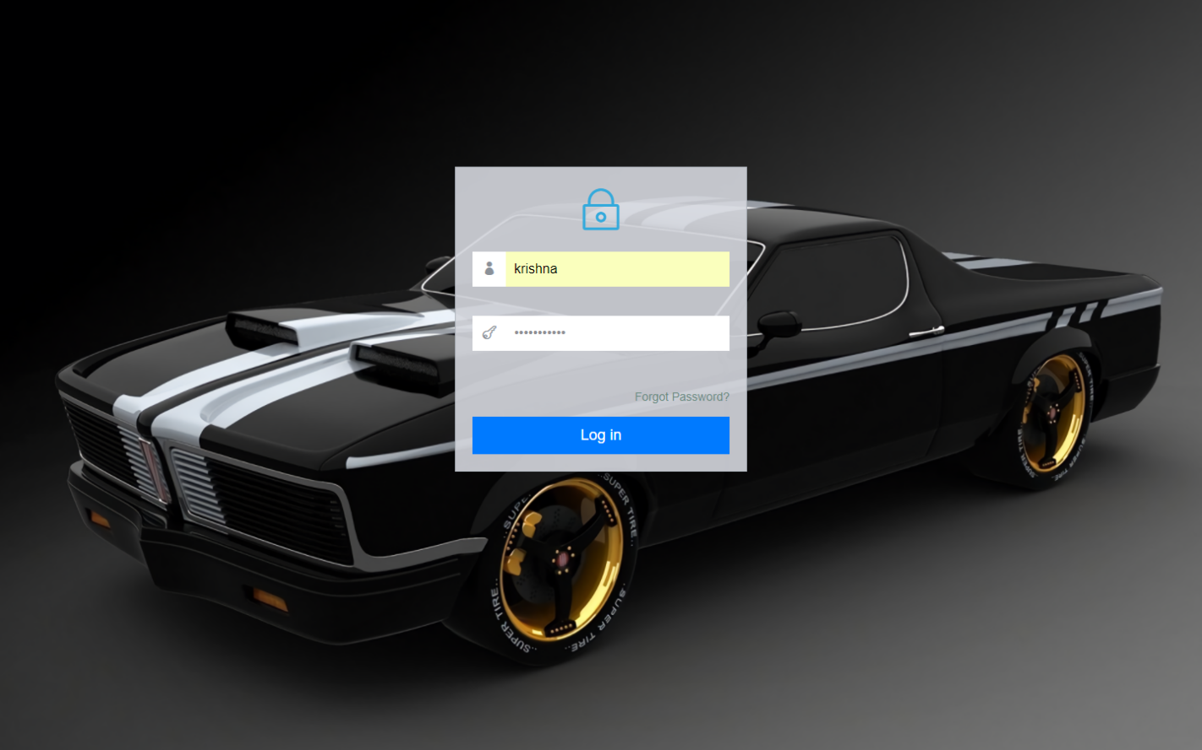

**Admin Home:**

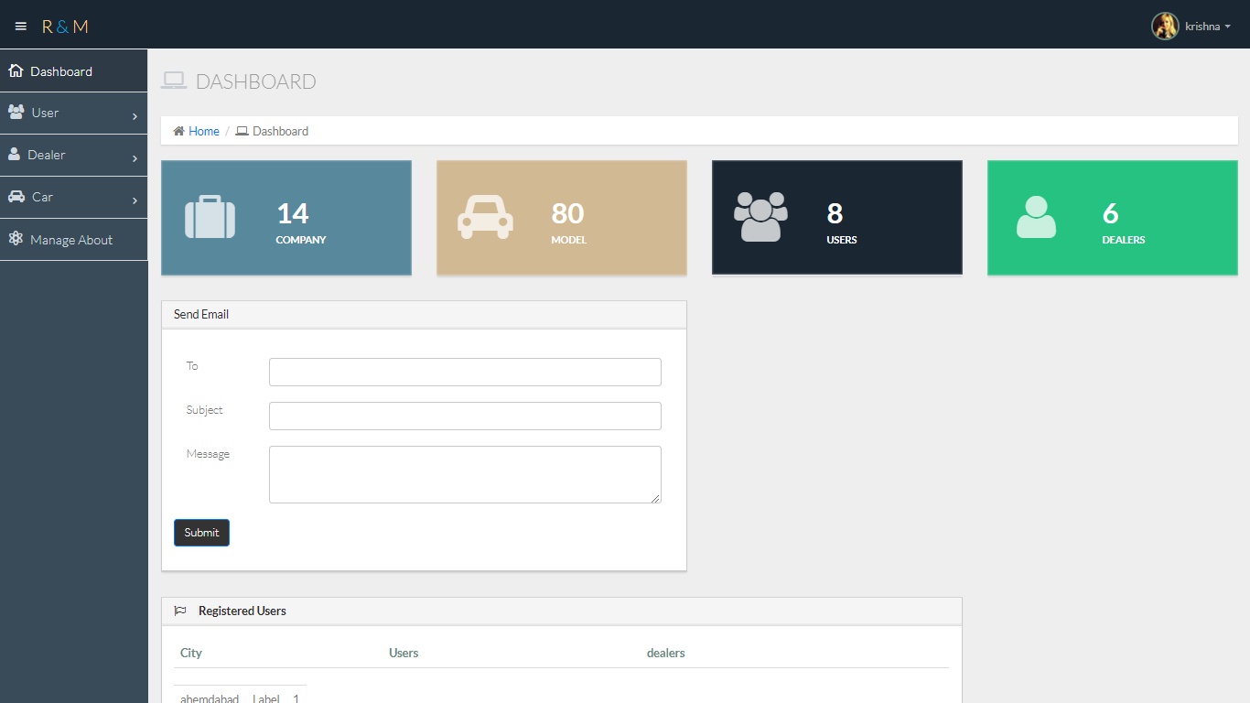

**Manage Admin Details:**

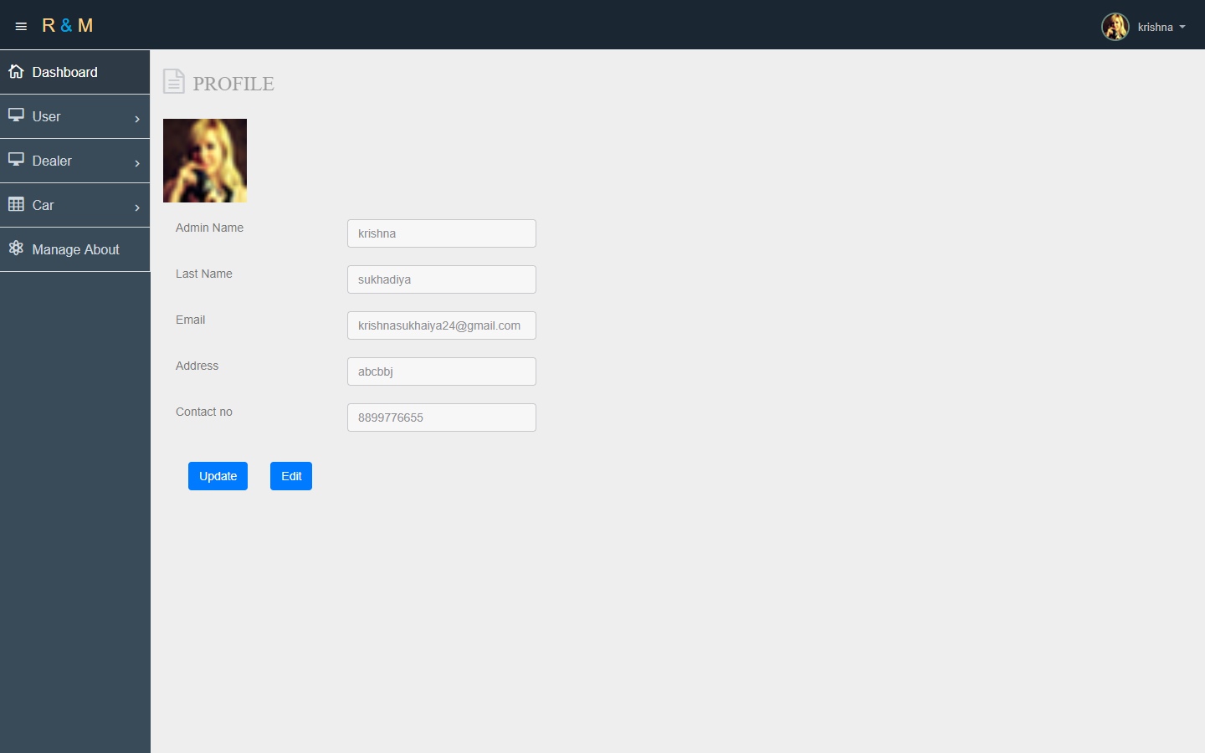

**Manage User Detail:**

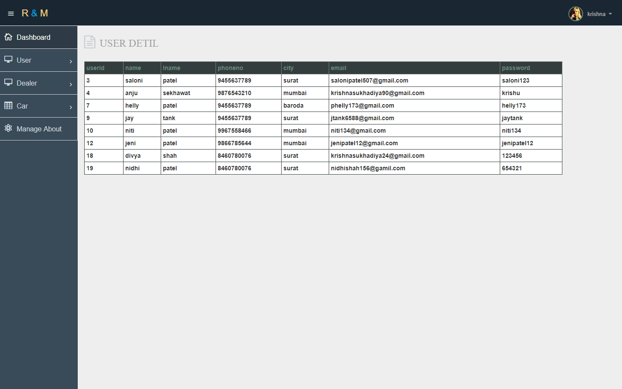

**Manage Test-Drive Booking:**

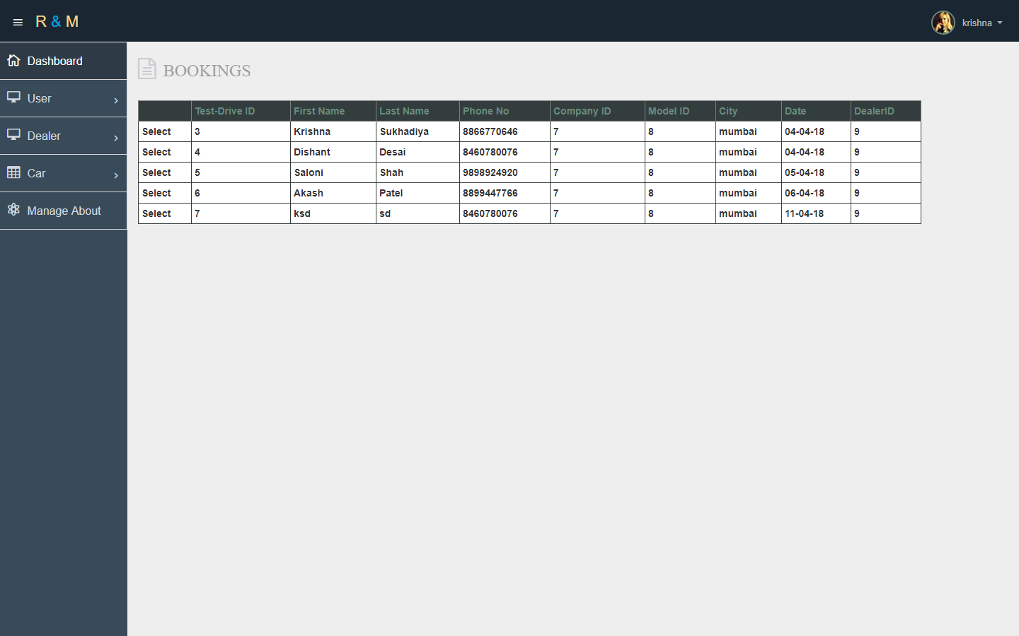

**Manage Events:**

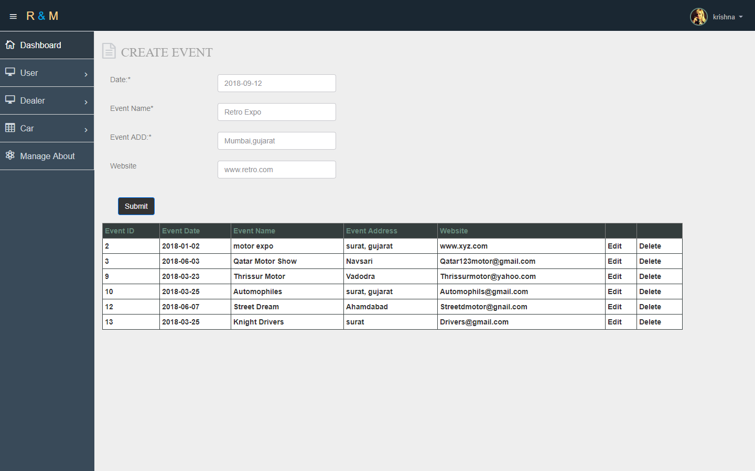

**View Dealer Message:**

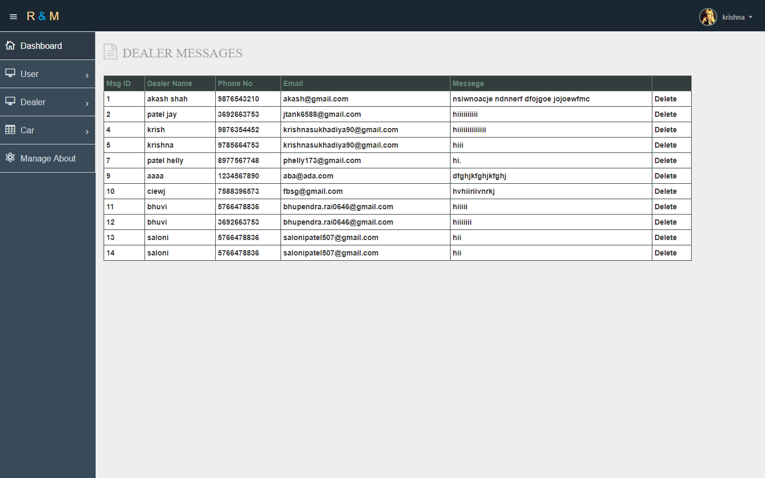

**Manage Company Details:**

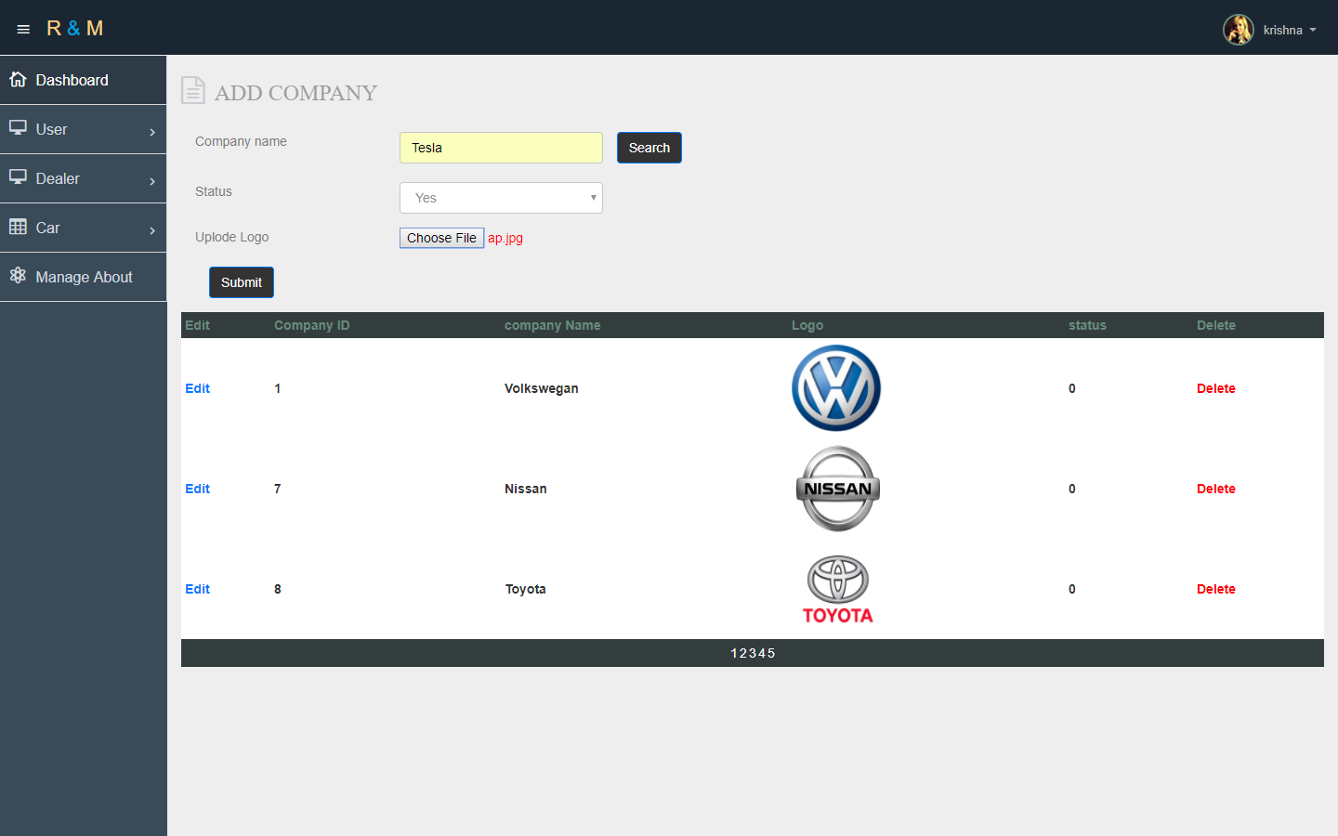

**Manage Model Details:**

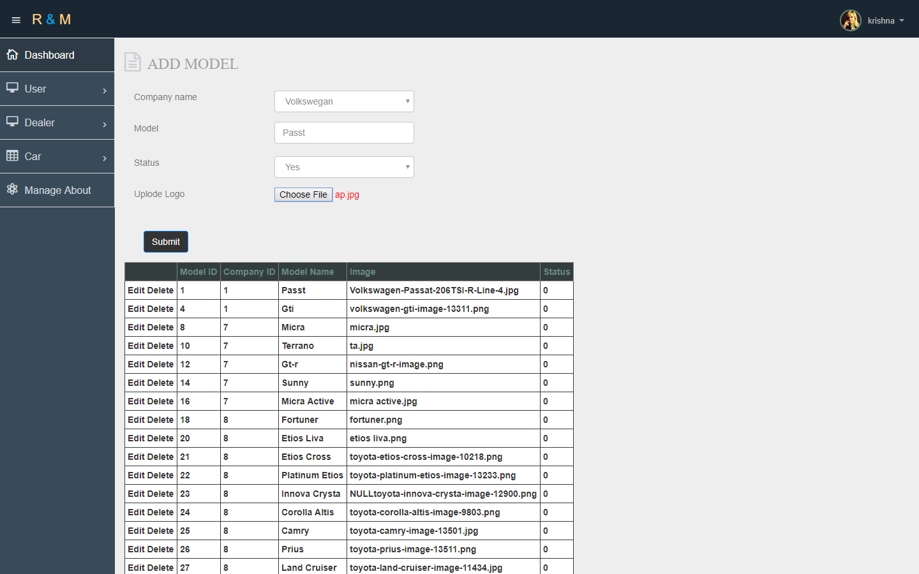

**Manage Version Details:**

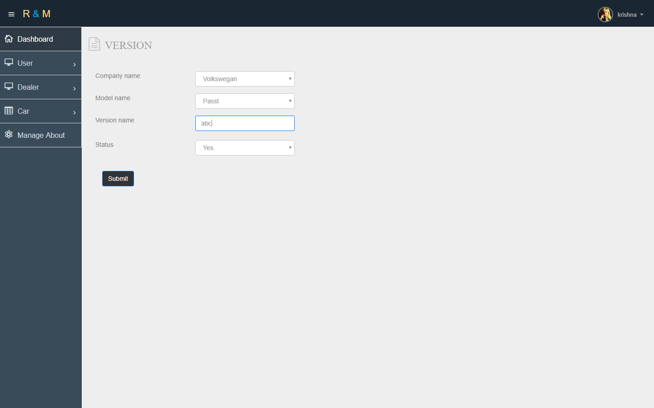

**Manage Color Details:**

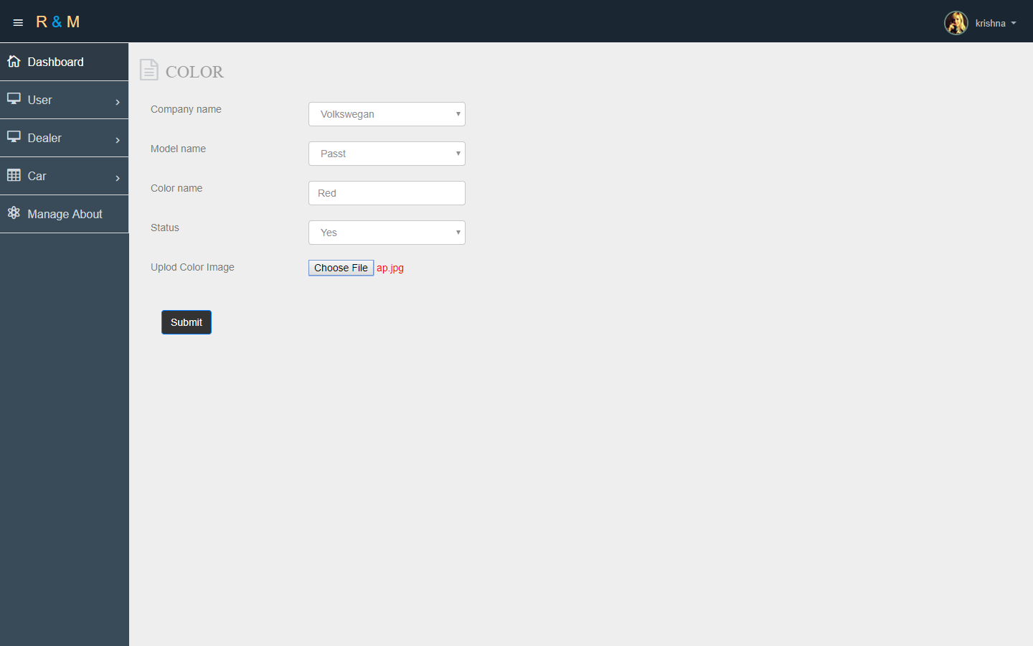

**Manage Car Details:**

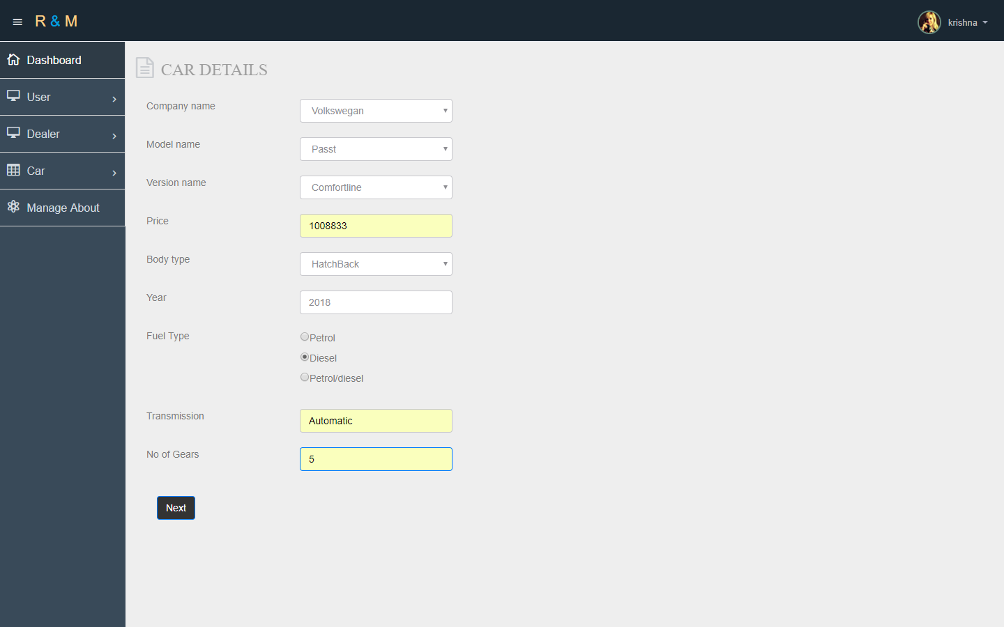

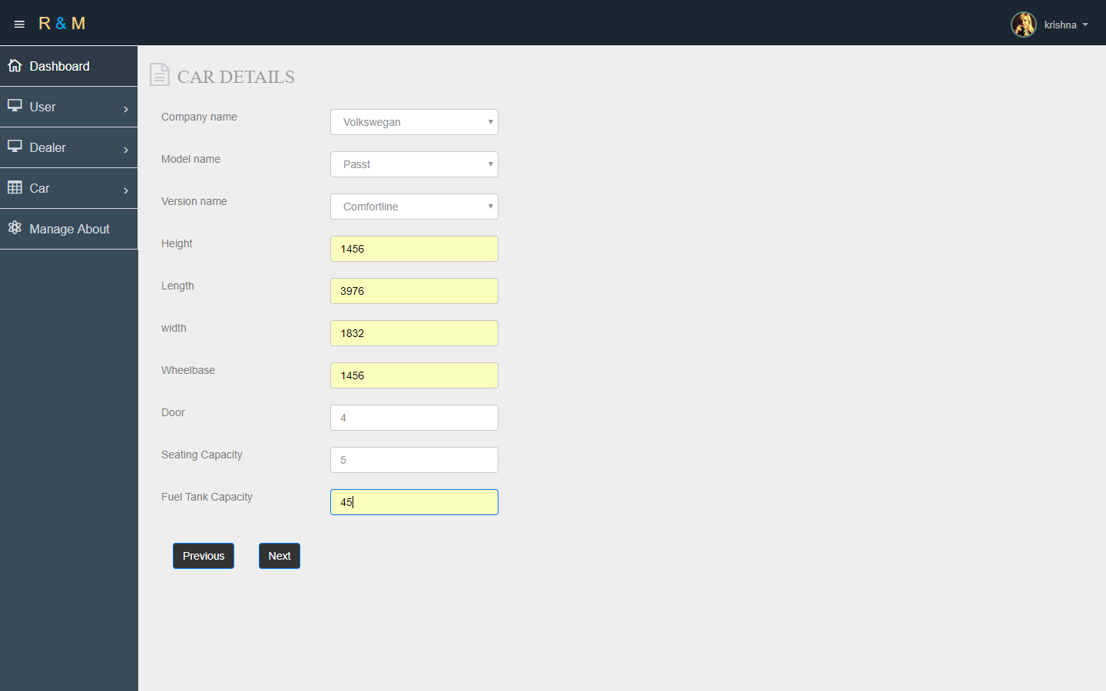

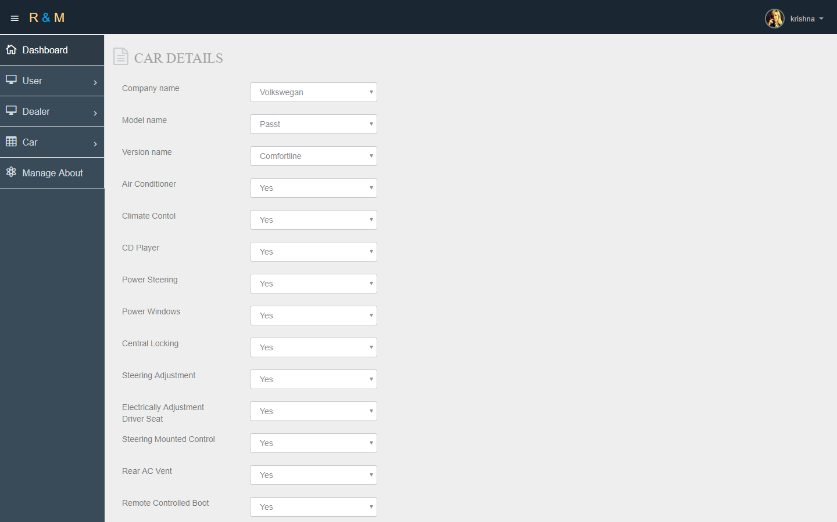

**Manage Car Image Details:**

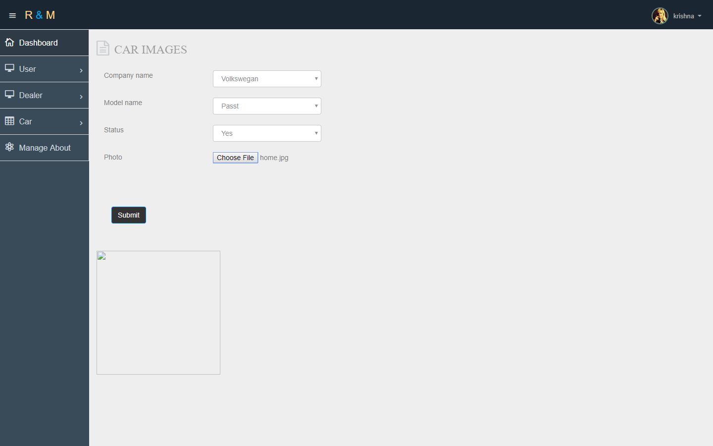

**View Car Details:**

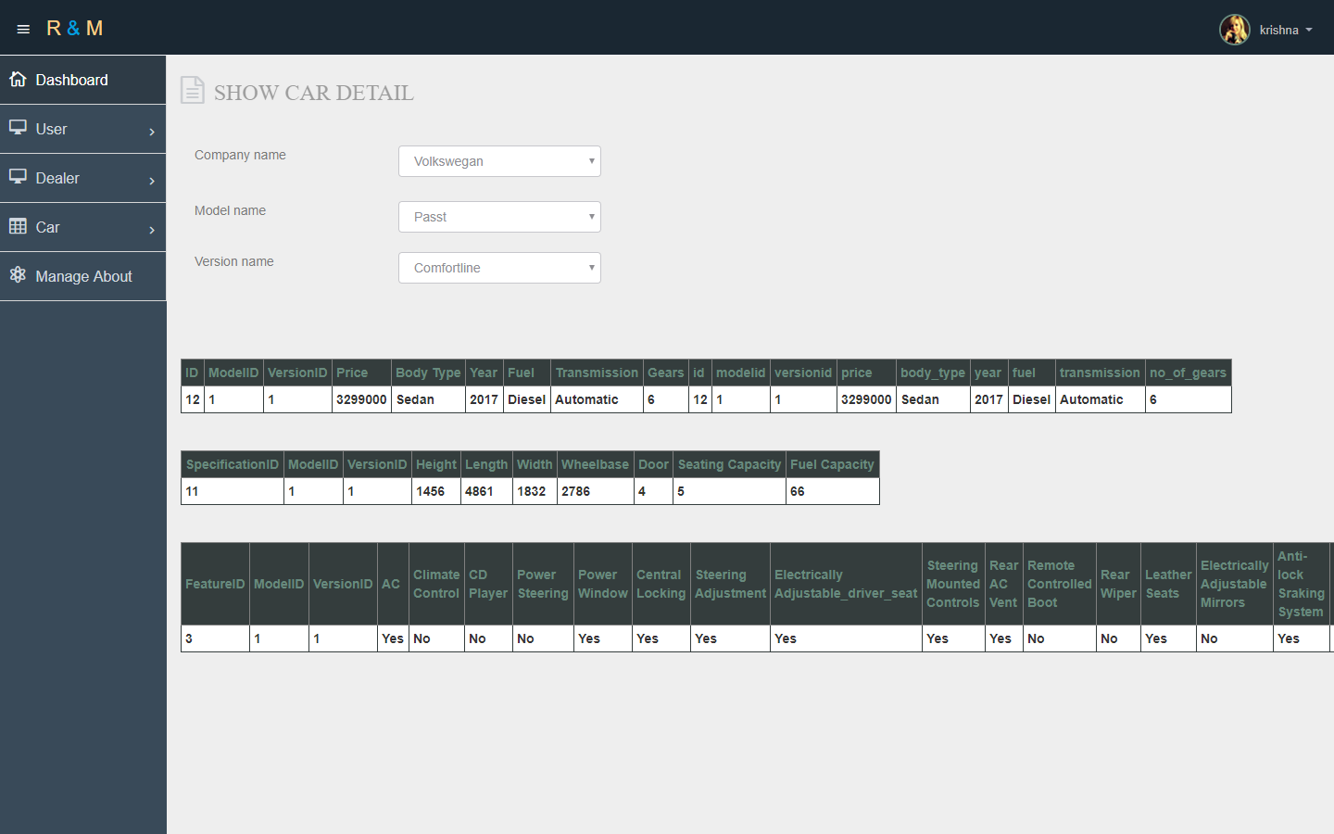

**Manage Upcoming Car Details:**

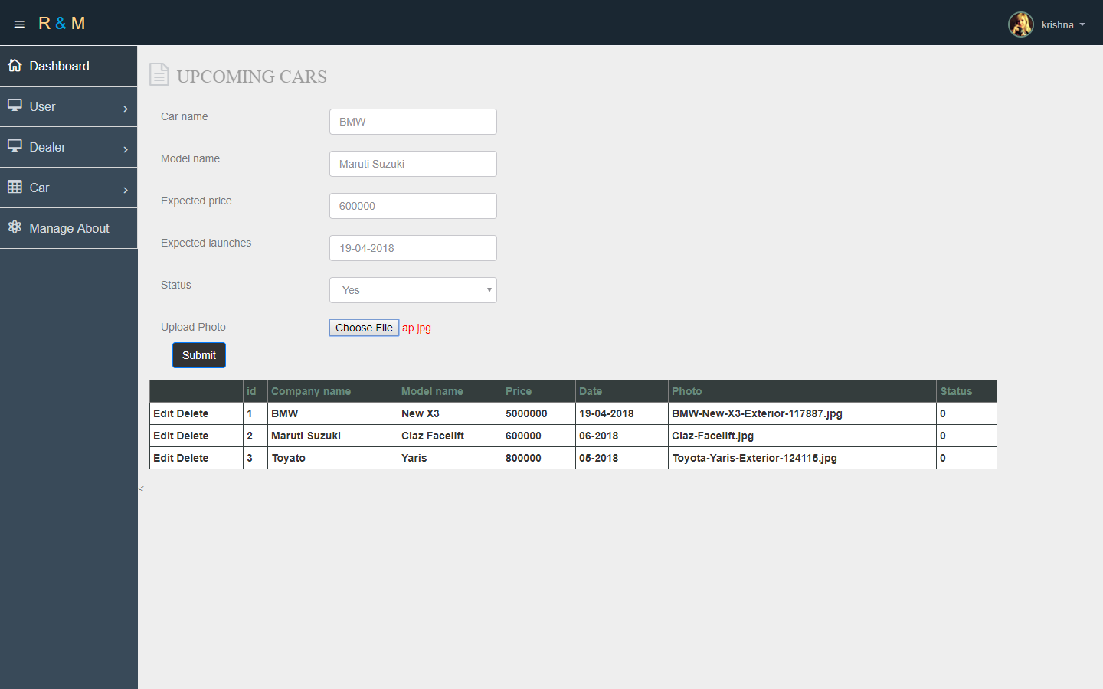

**Manage Popular Car Details:**

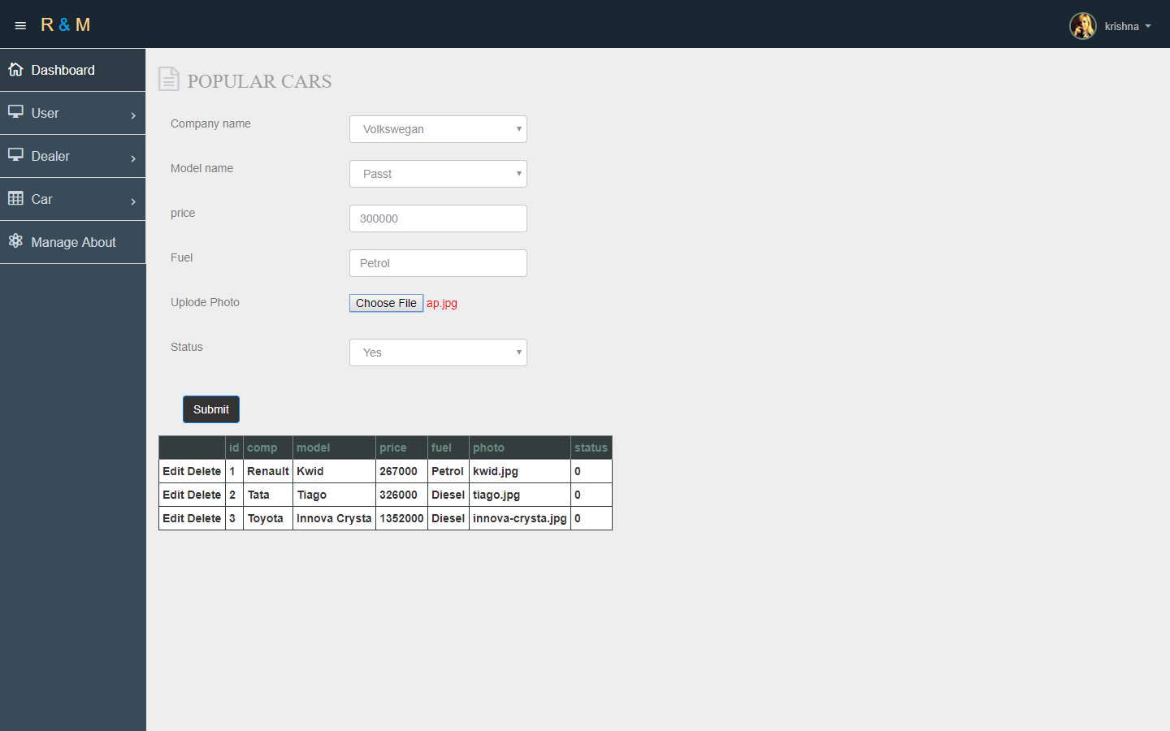

**Manage Just Launch Car Details:**

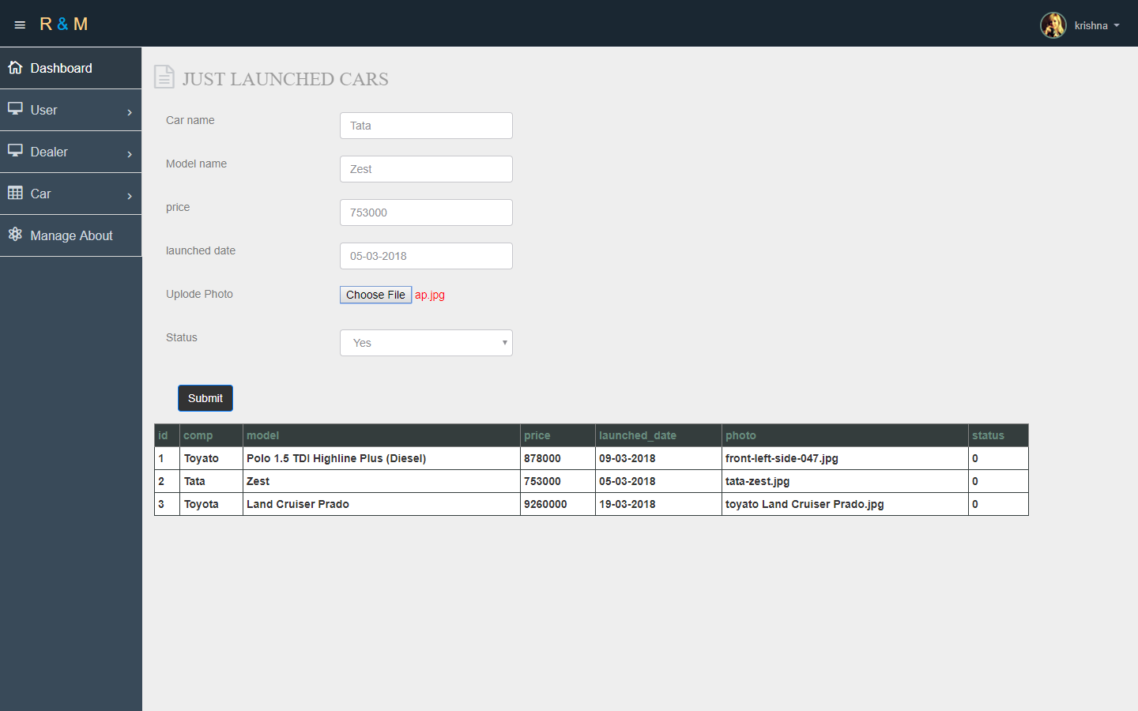

**Manage About Us Page Details:**

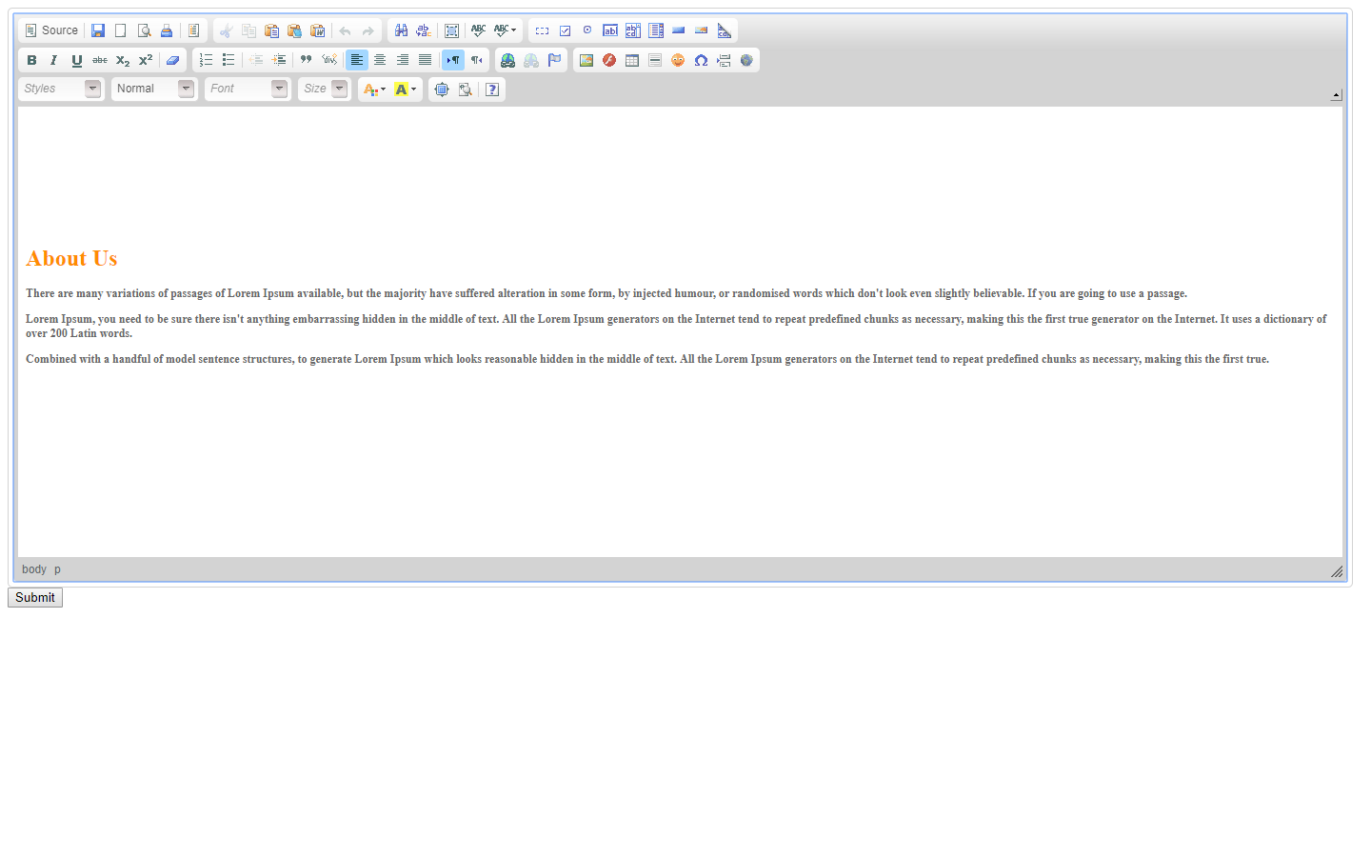

**Dealer:**

**Log-in:**

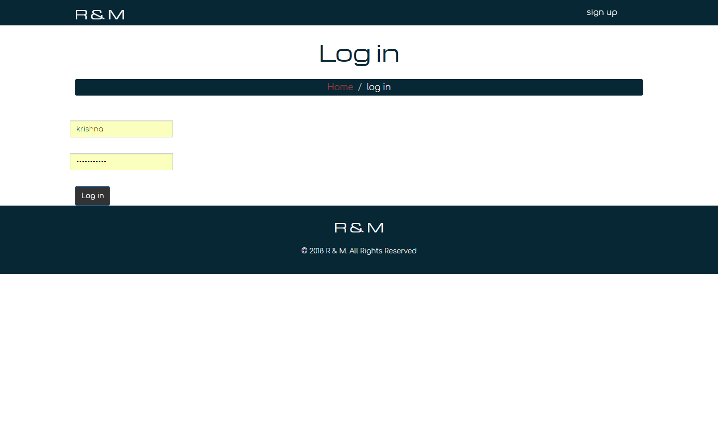

**Sign-up:**

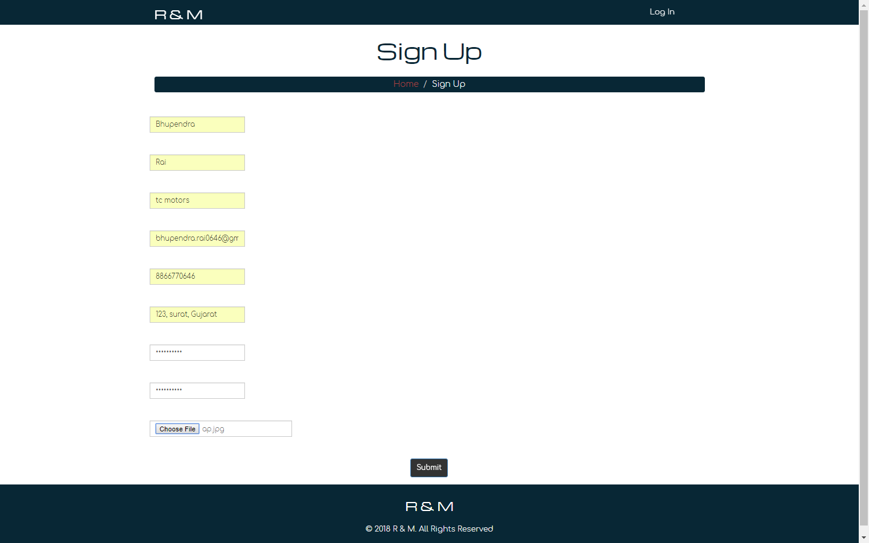

**Home:**

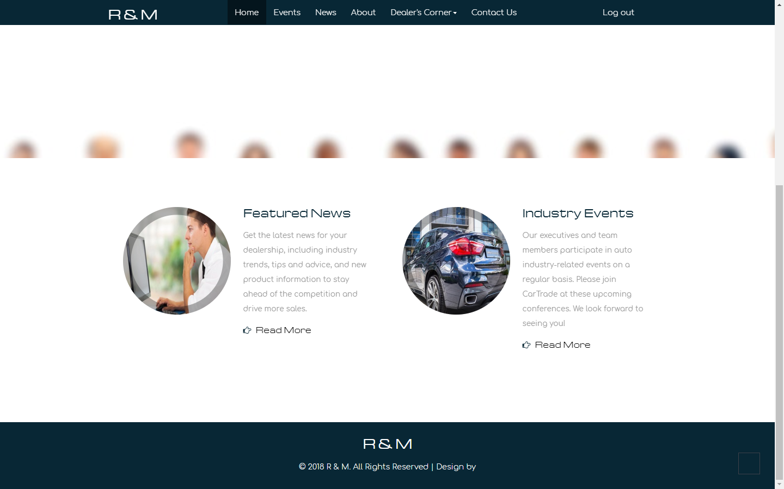

**View Events:**

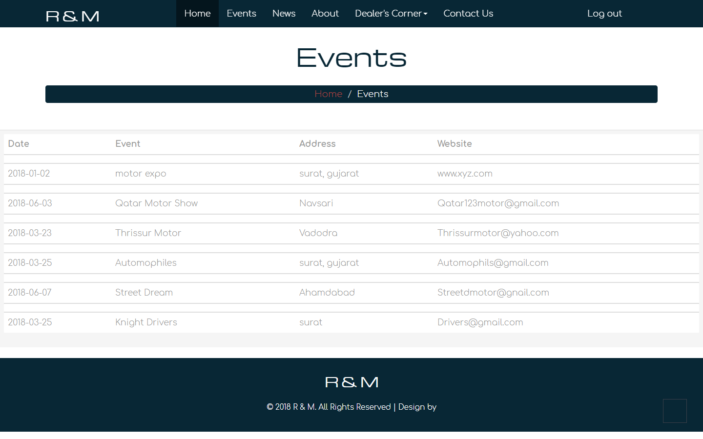

**View News:**

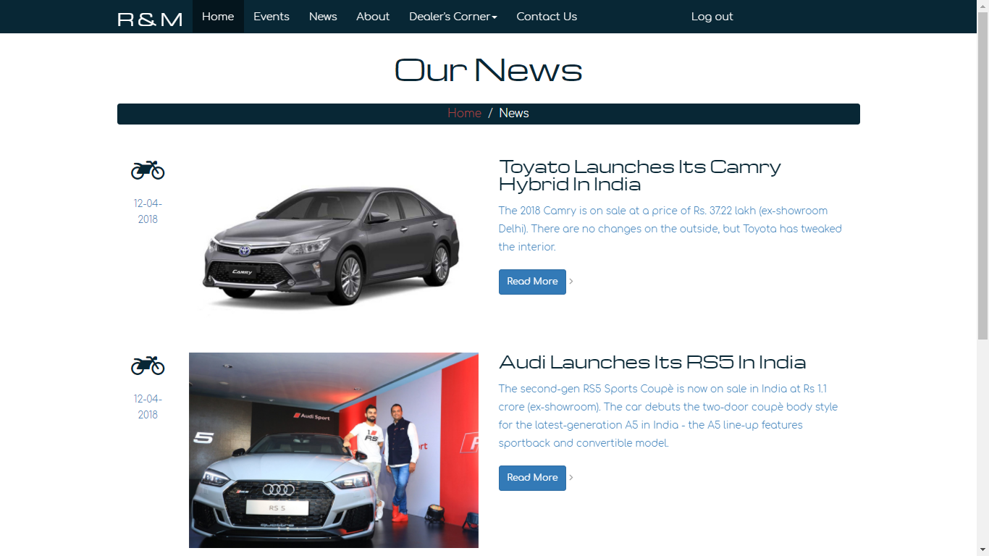

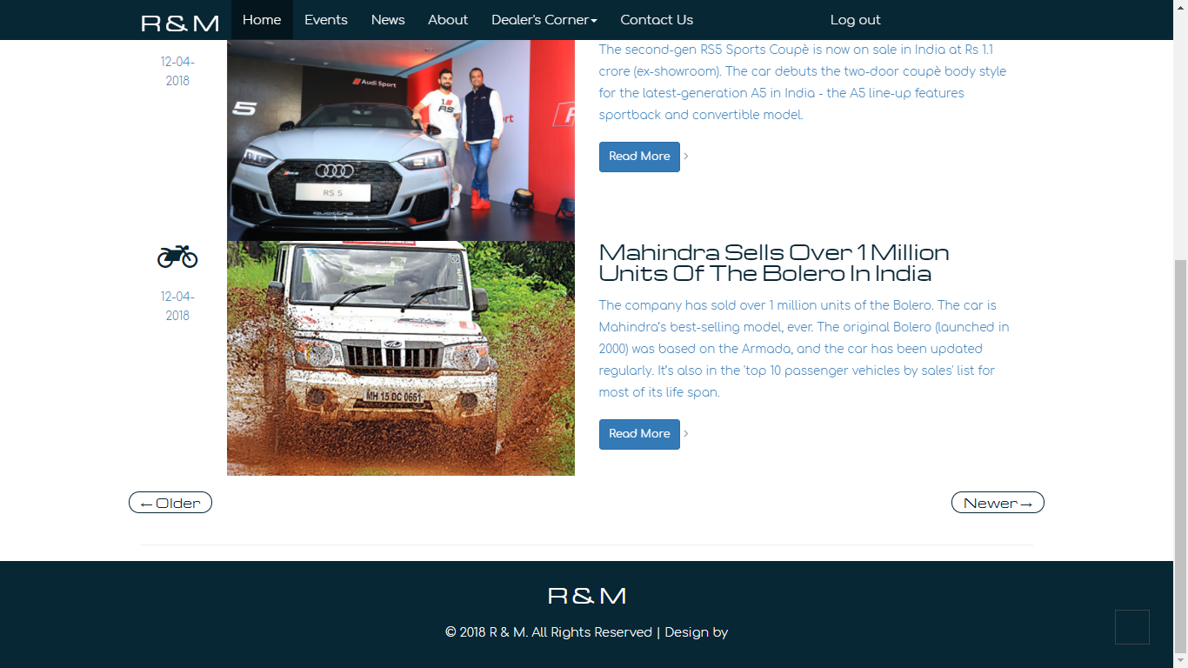

**Manage Dealer Model:**

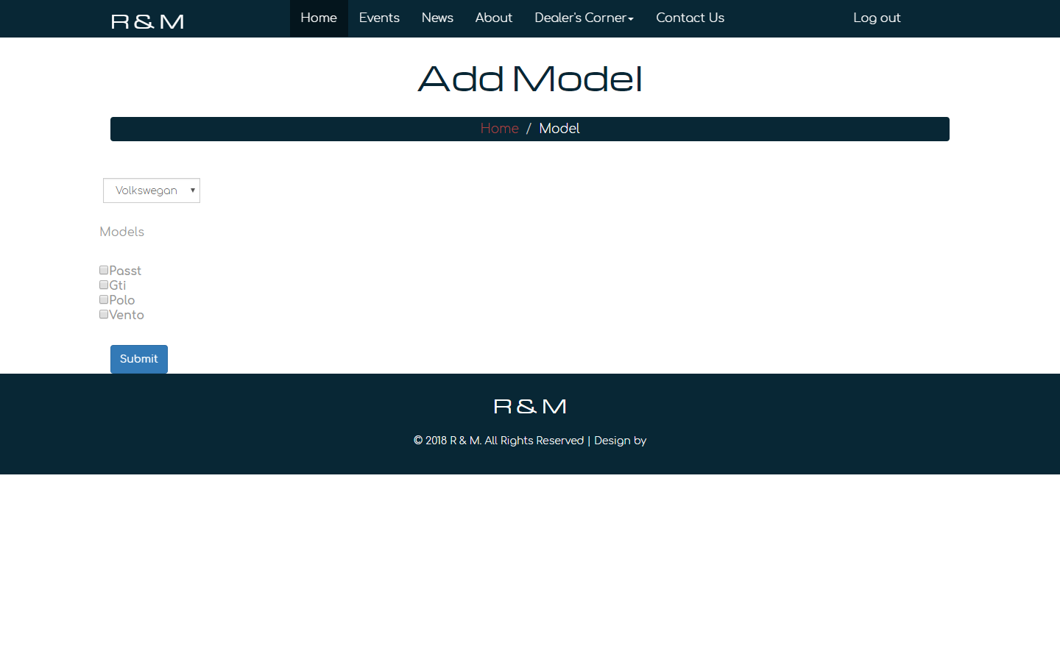

**Manage Test-Drive Bookings:**

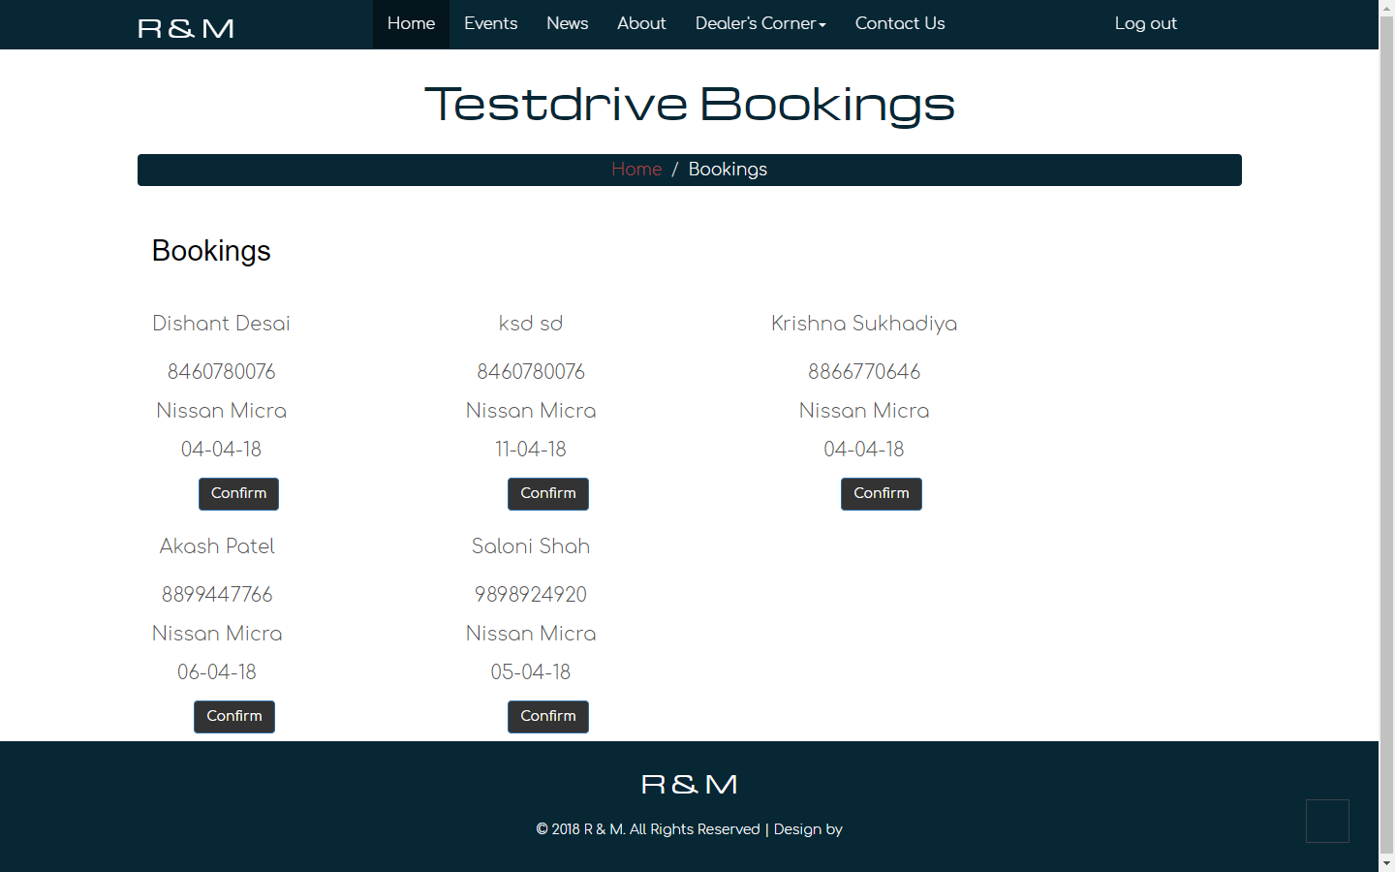

**View About Us:**

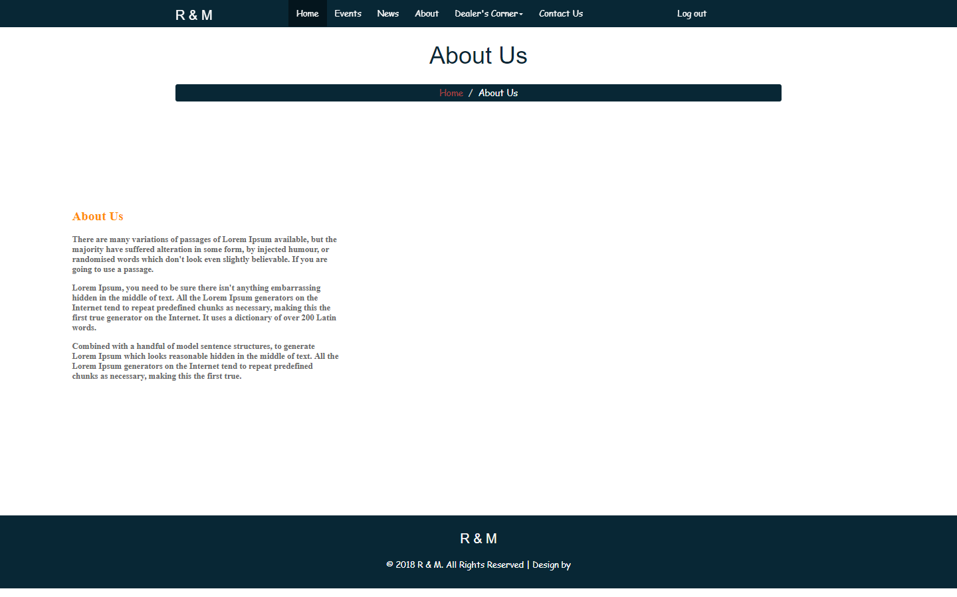

**Contact Us:**

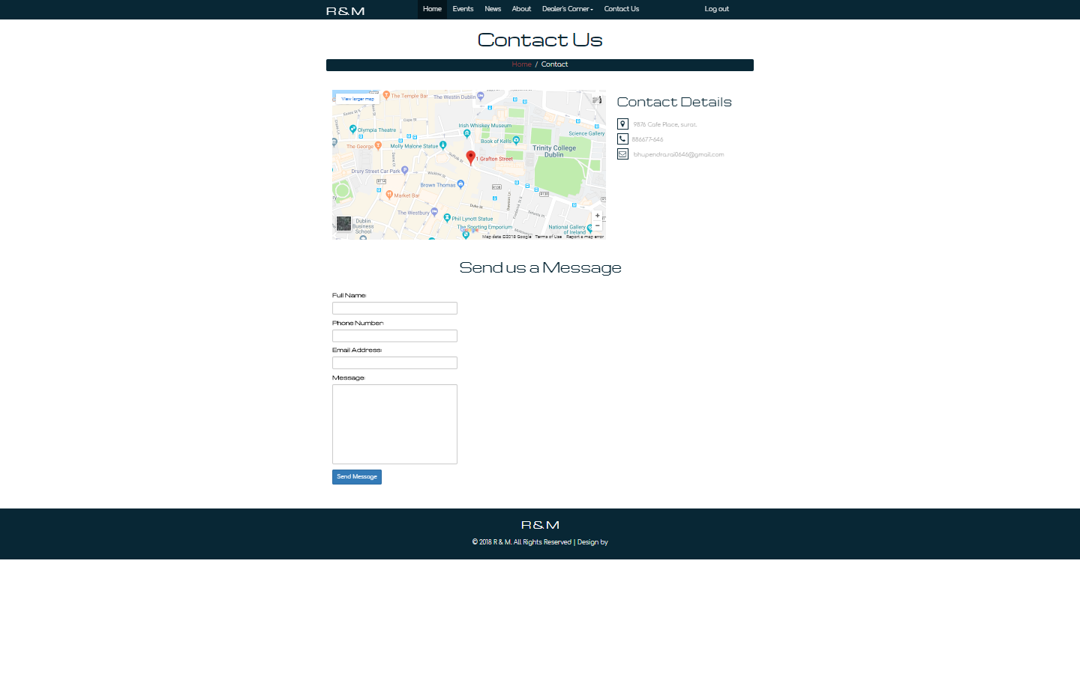

**User:**

**Log-In/Sign Up:**

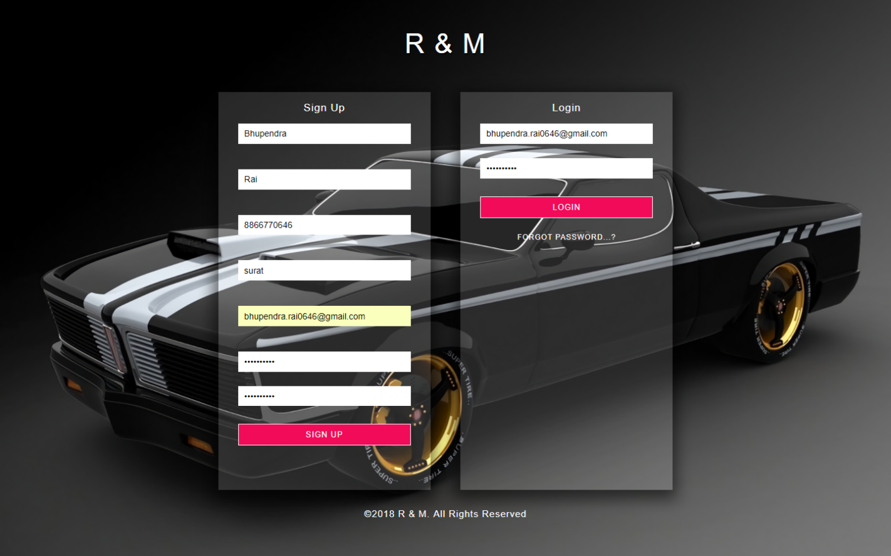

**Password Recovery Part-1:**

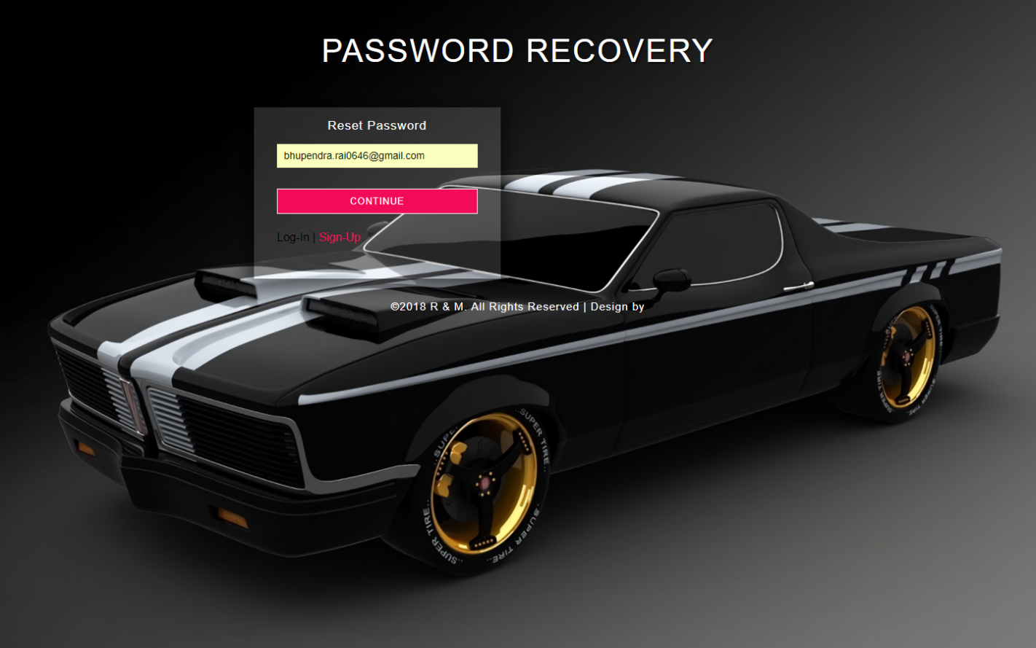

**Password Recovery part-2:**

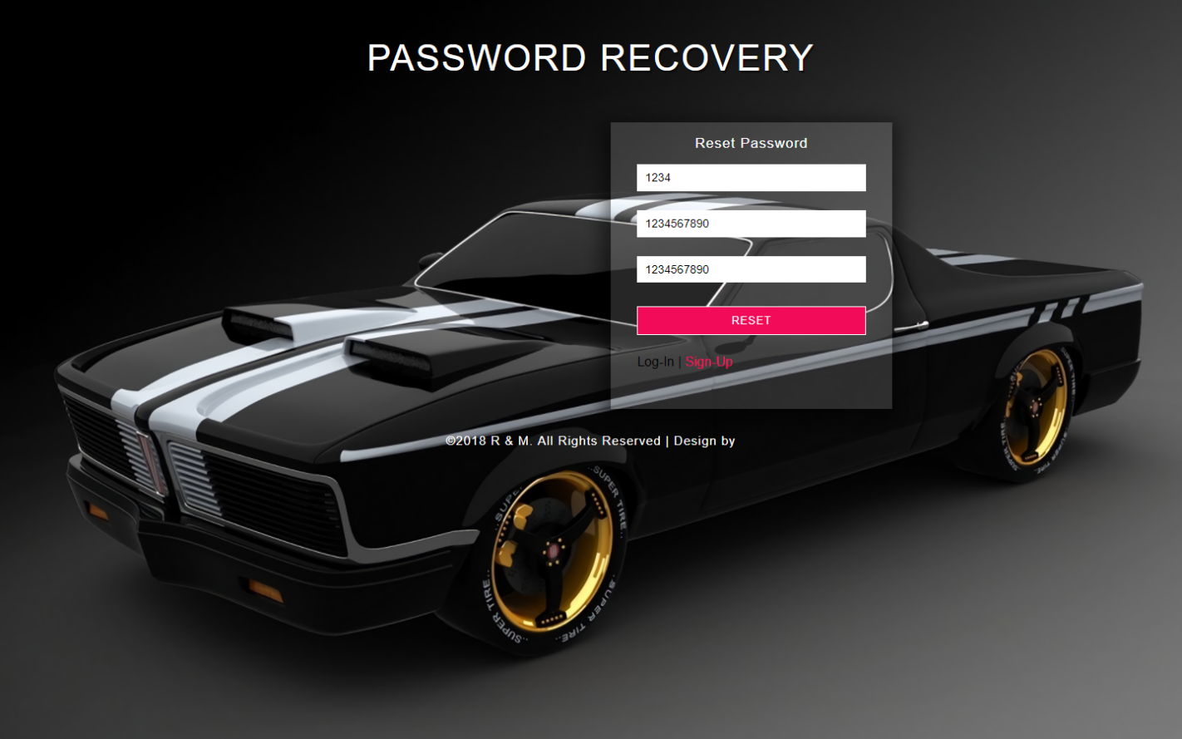

**Home:**

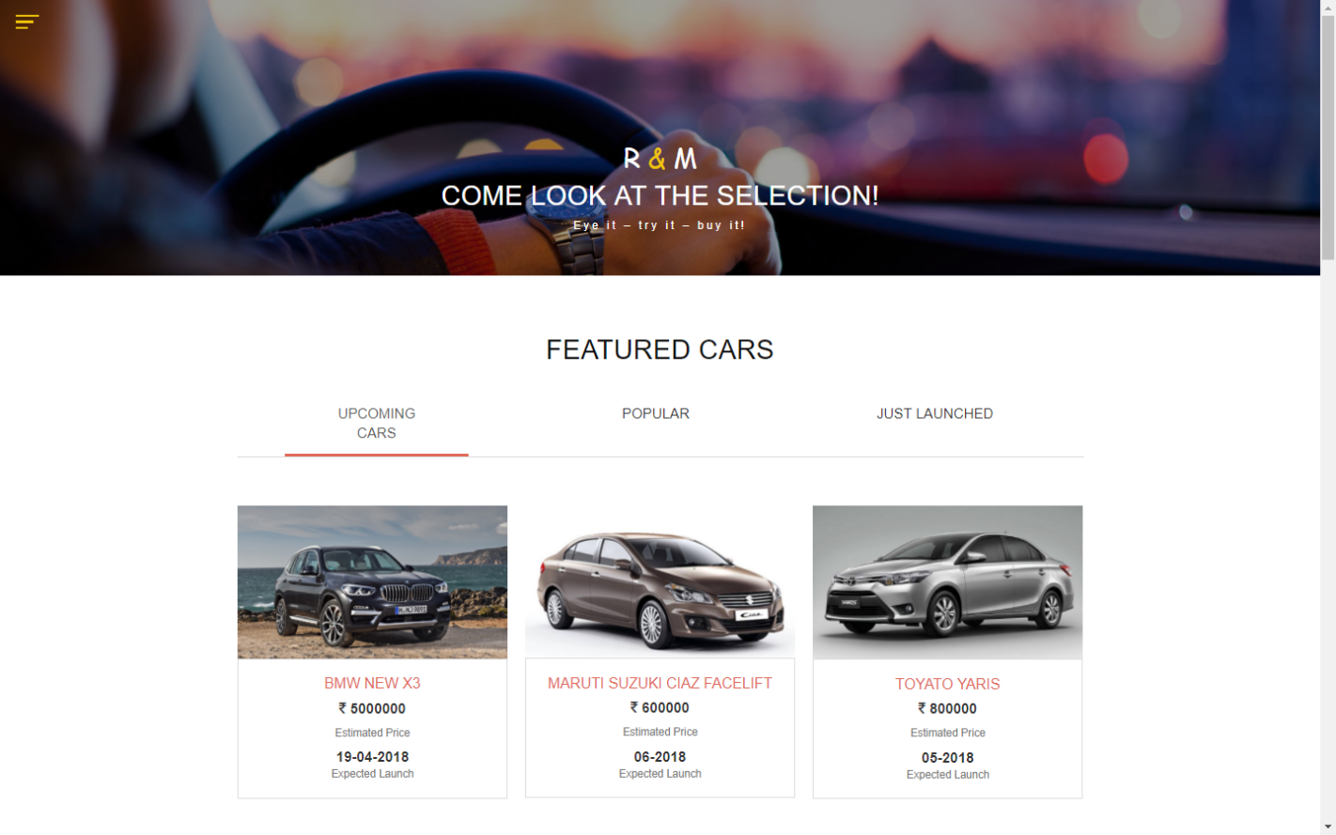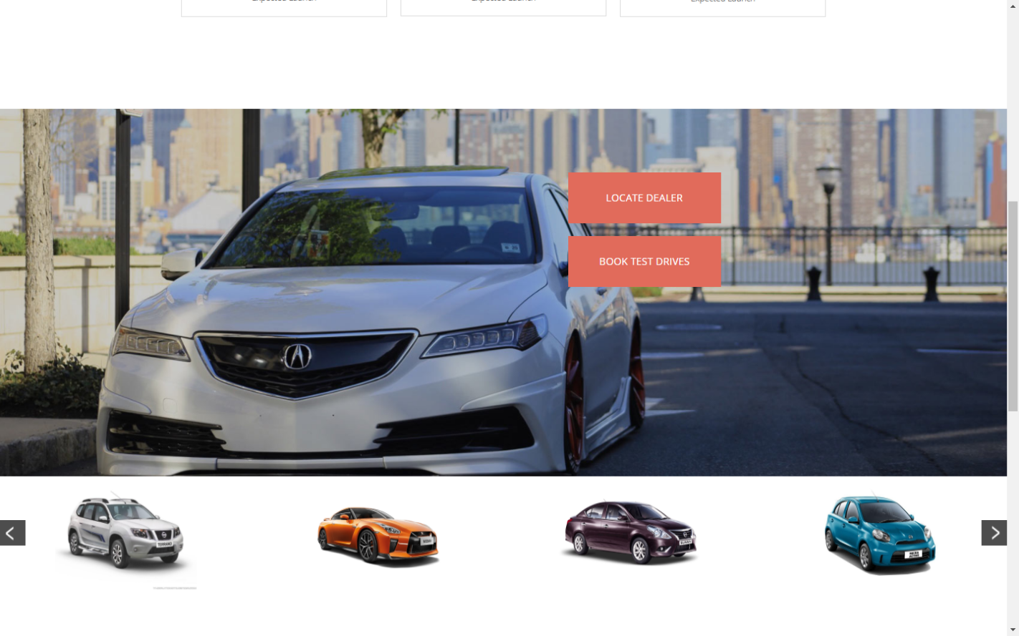

**Find Car(Body Type):**

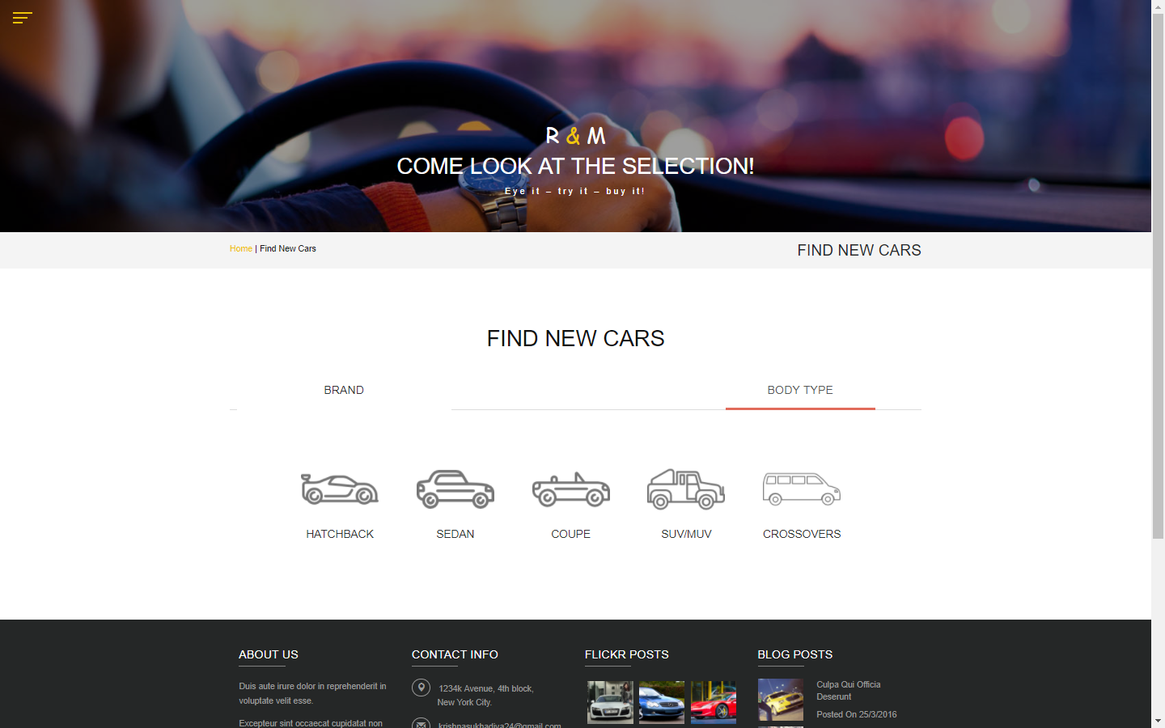

**Find Car(By company):**

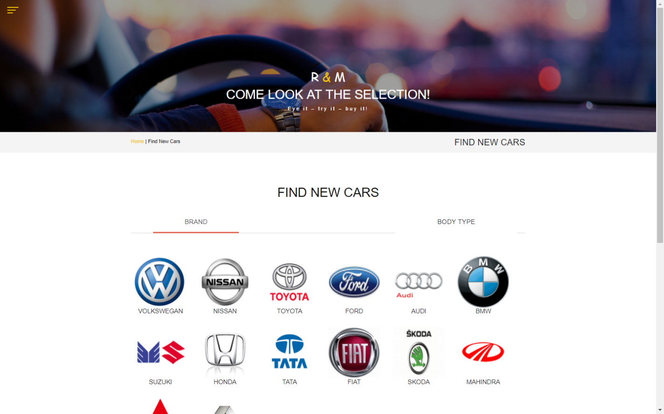

**Find Car(Result):**

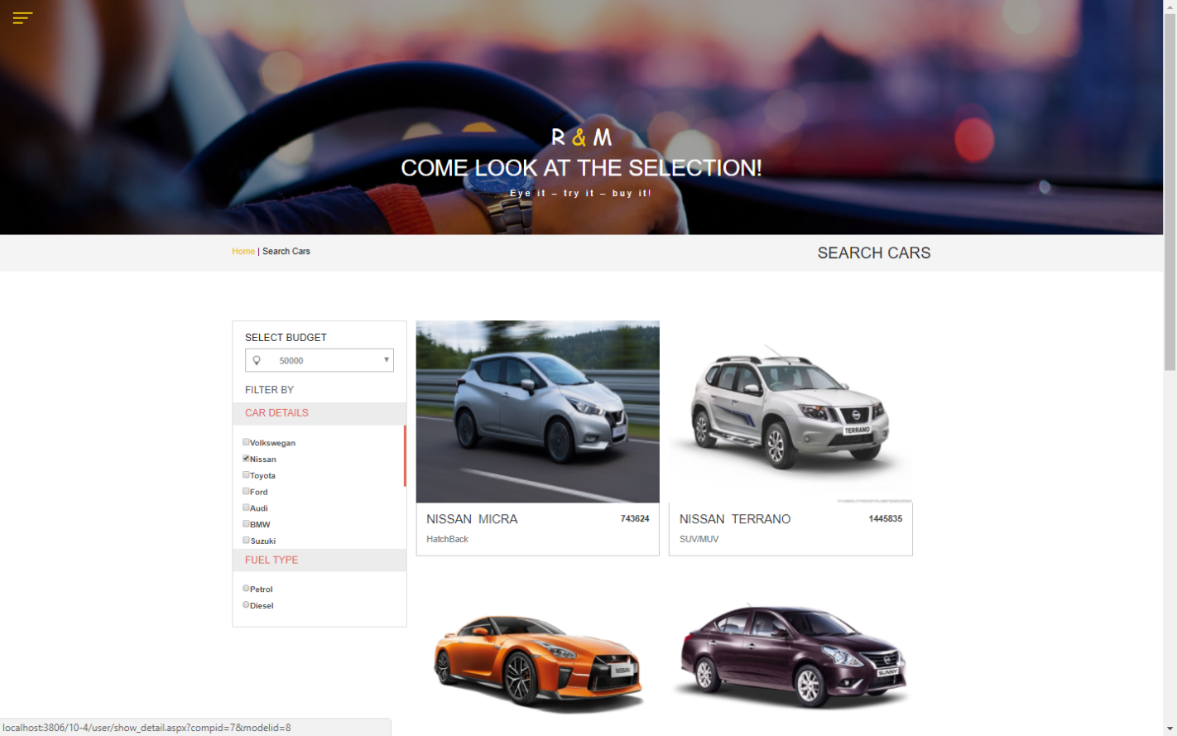

**Test-Drive Booking:**

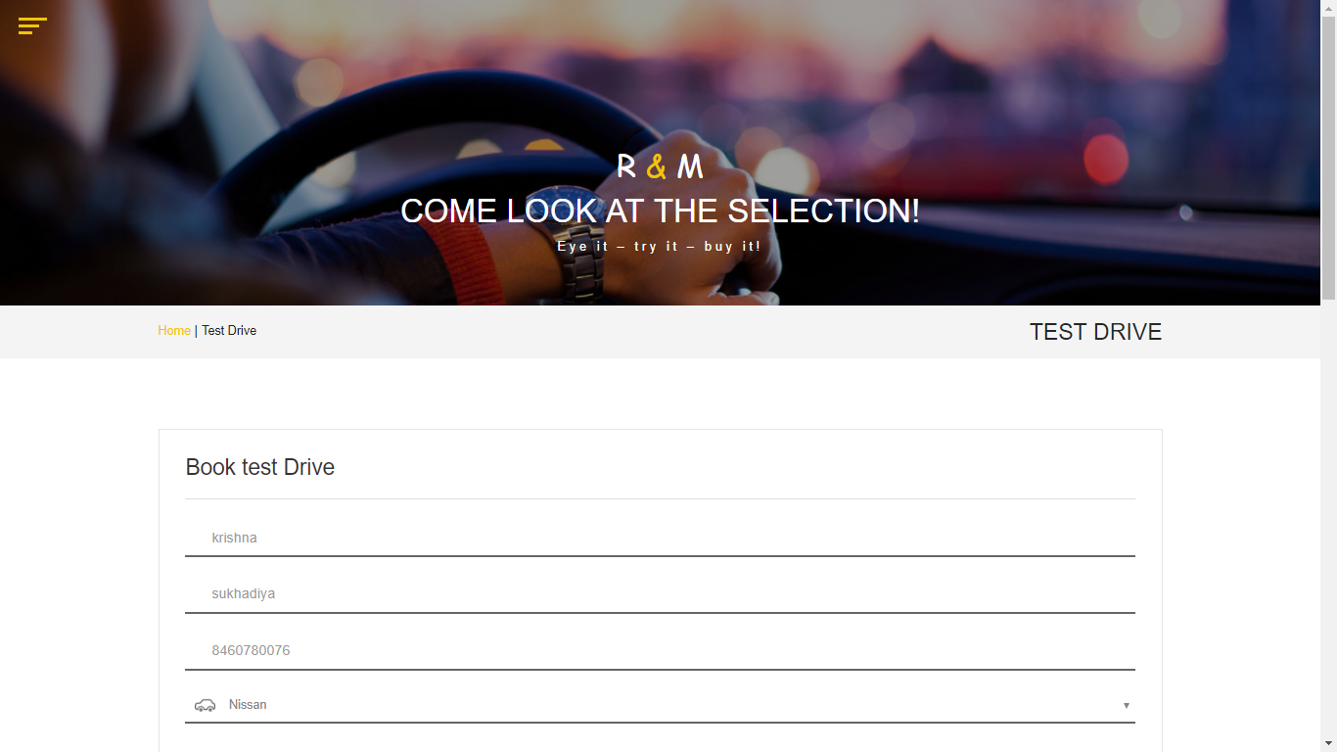 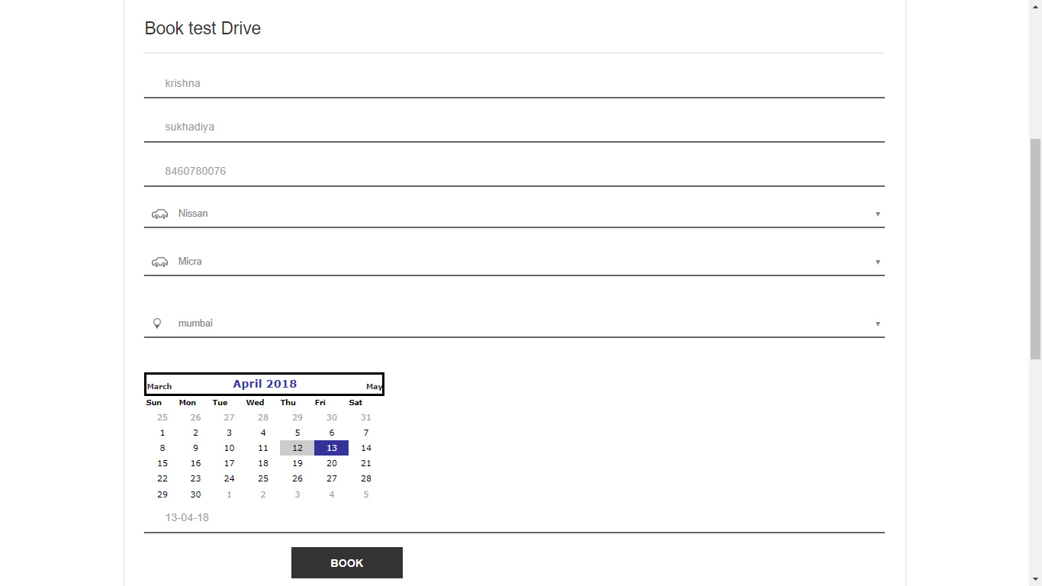

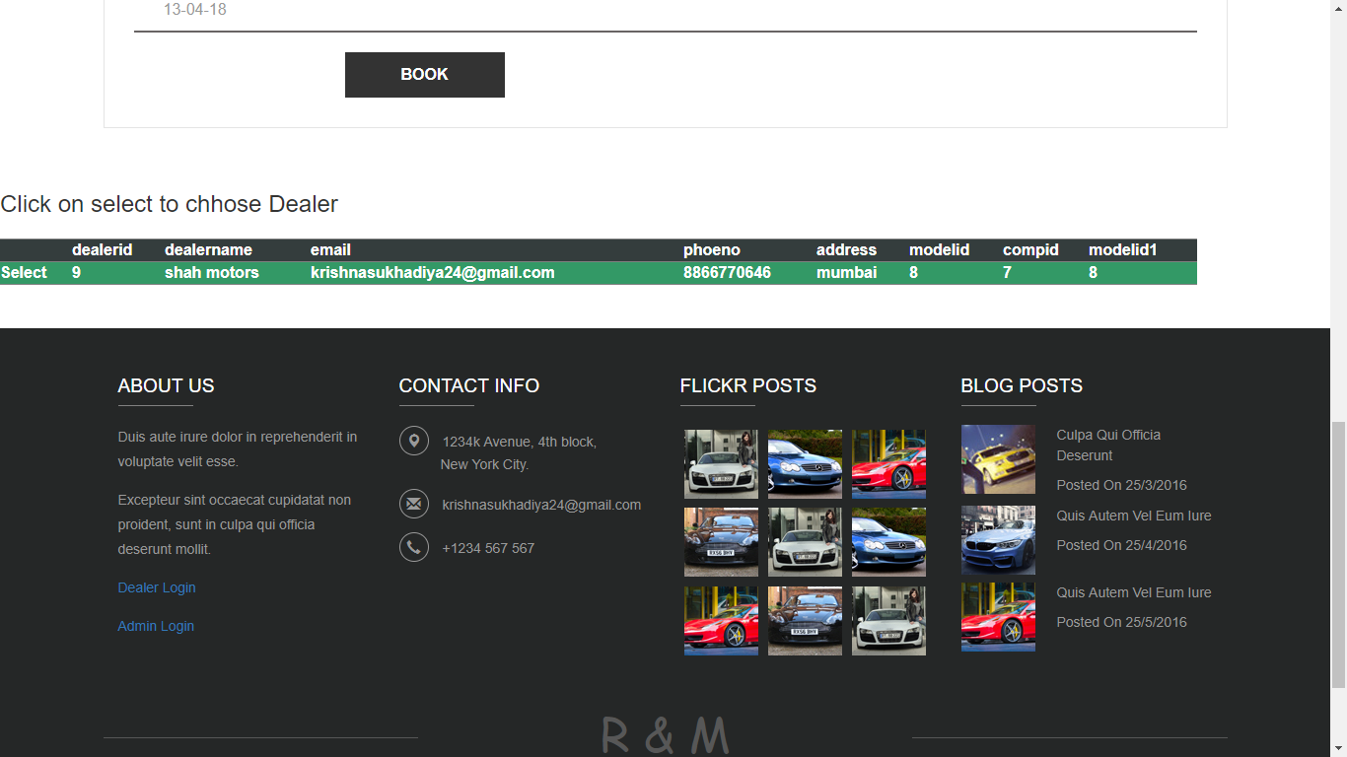

**Locate Dealer:**

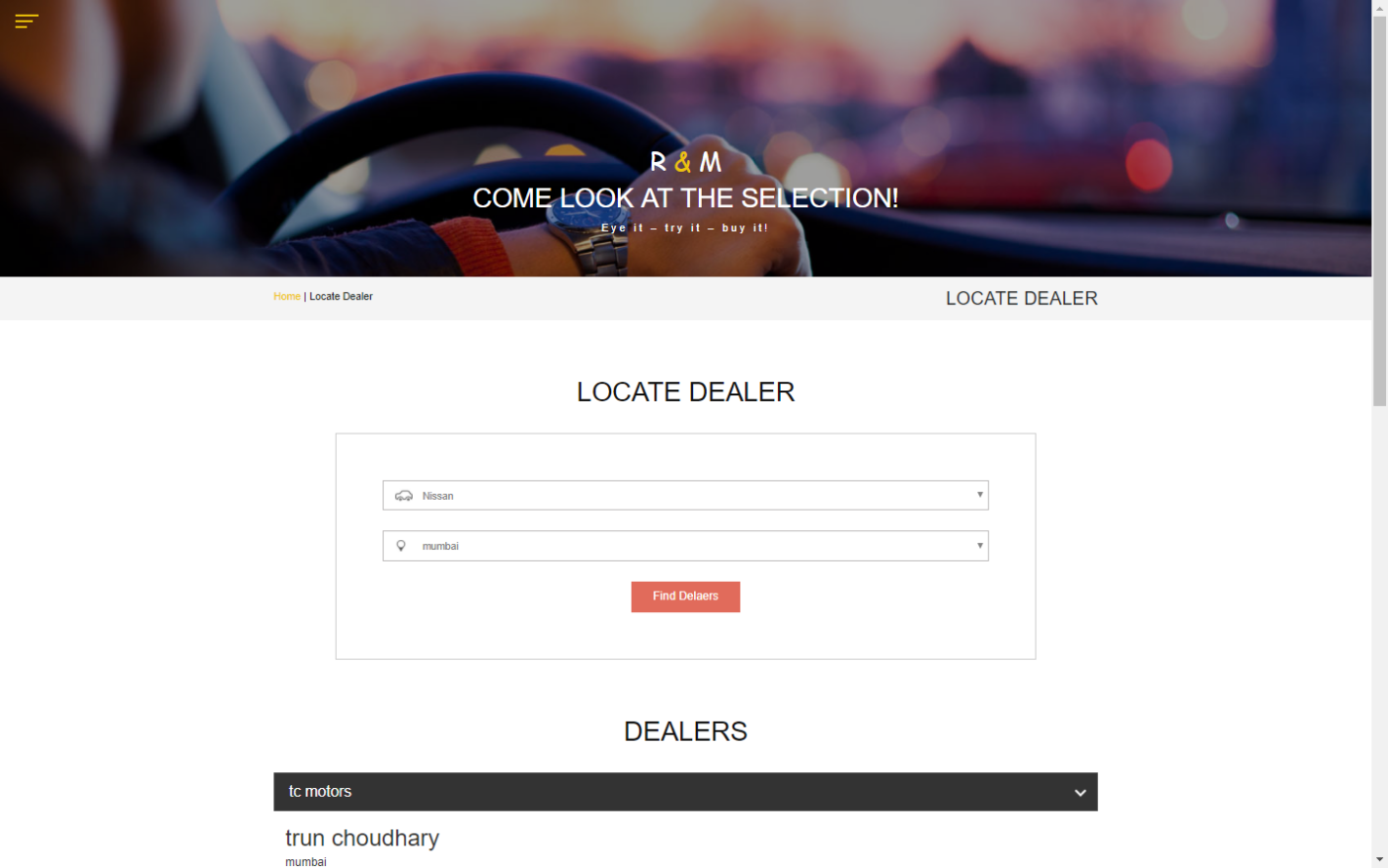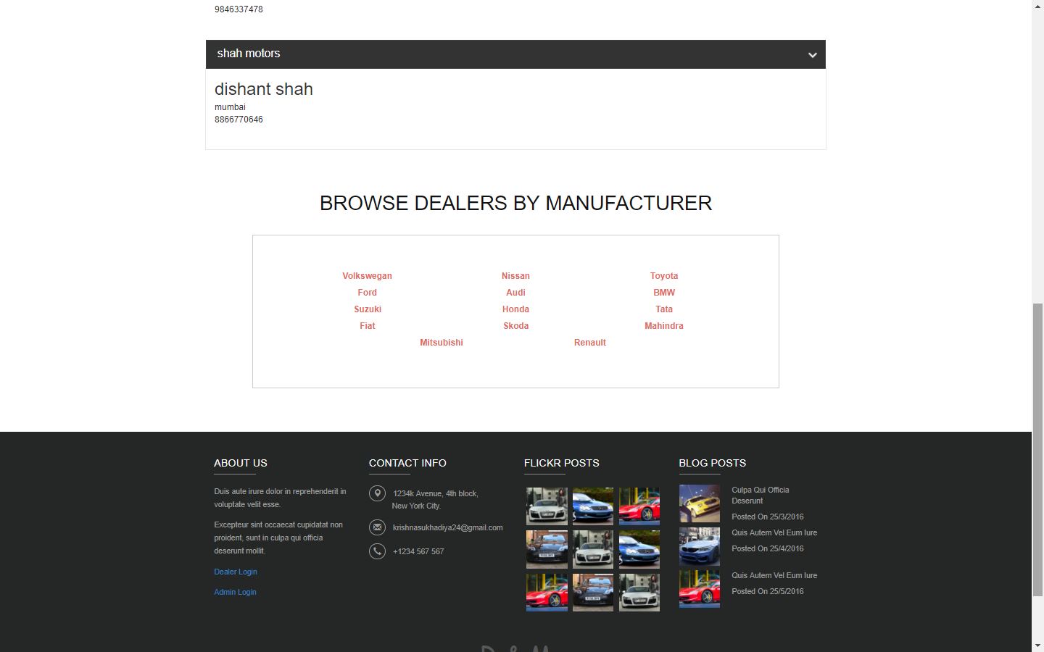

**Compare Two Cars:**

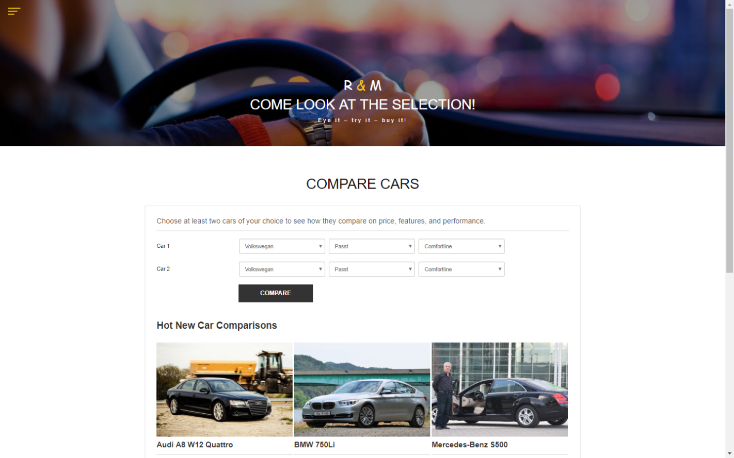

**Compare Two Cars(Result):**

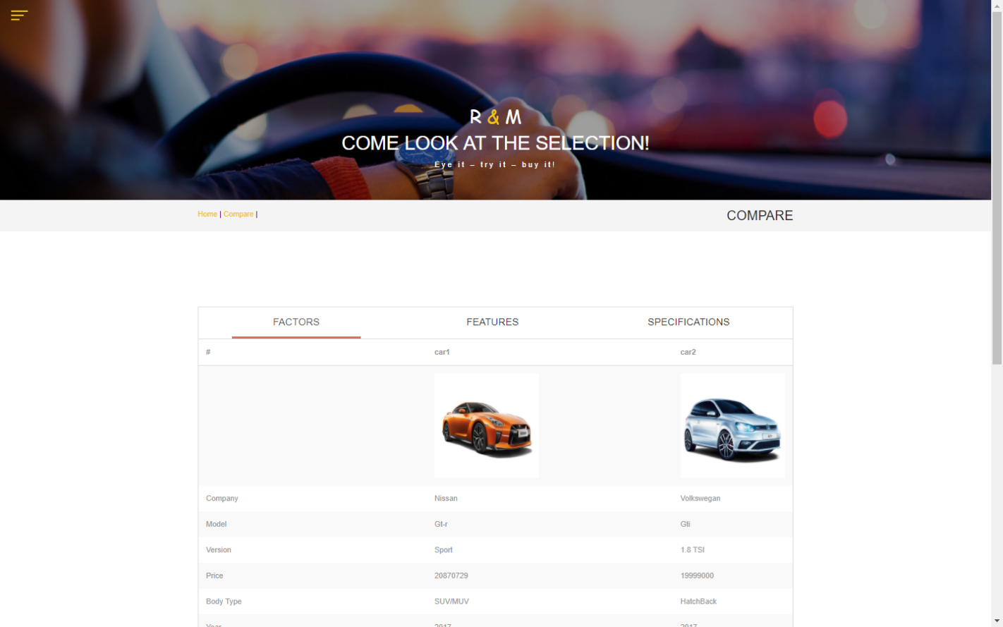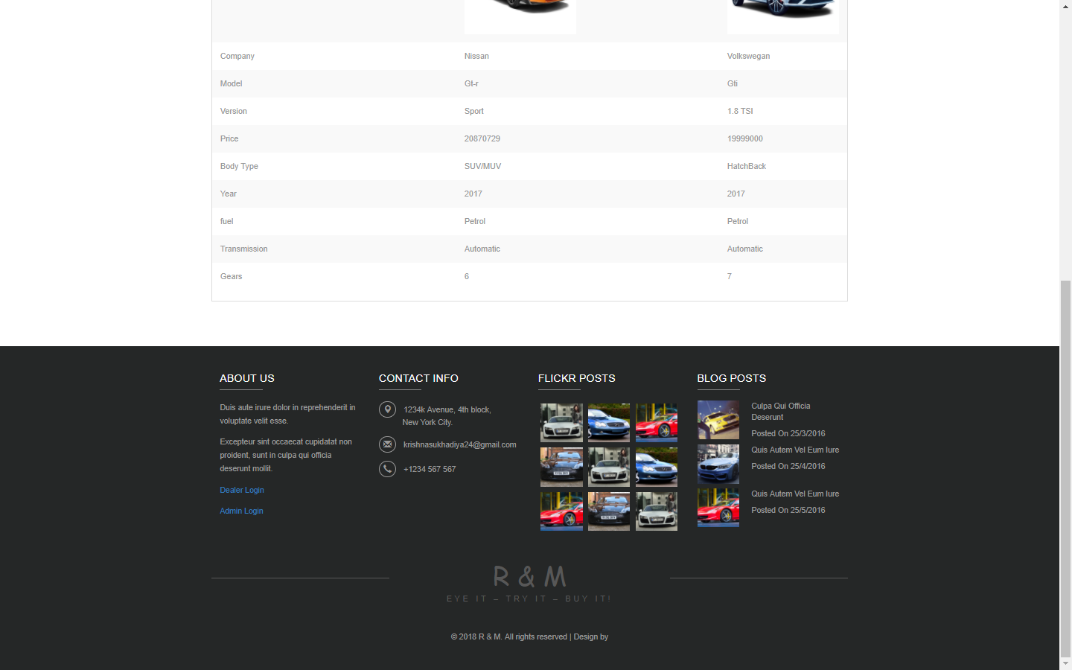

**View News:**

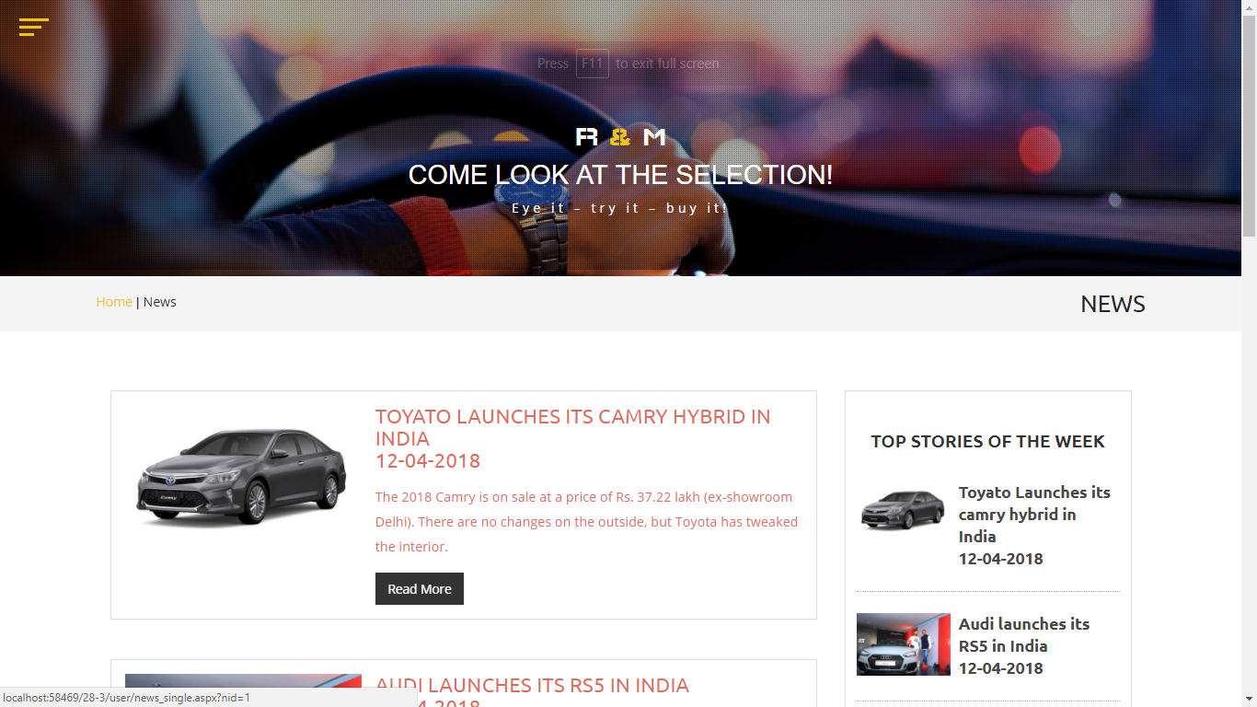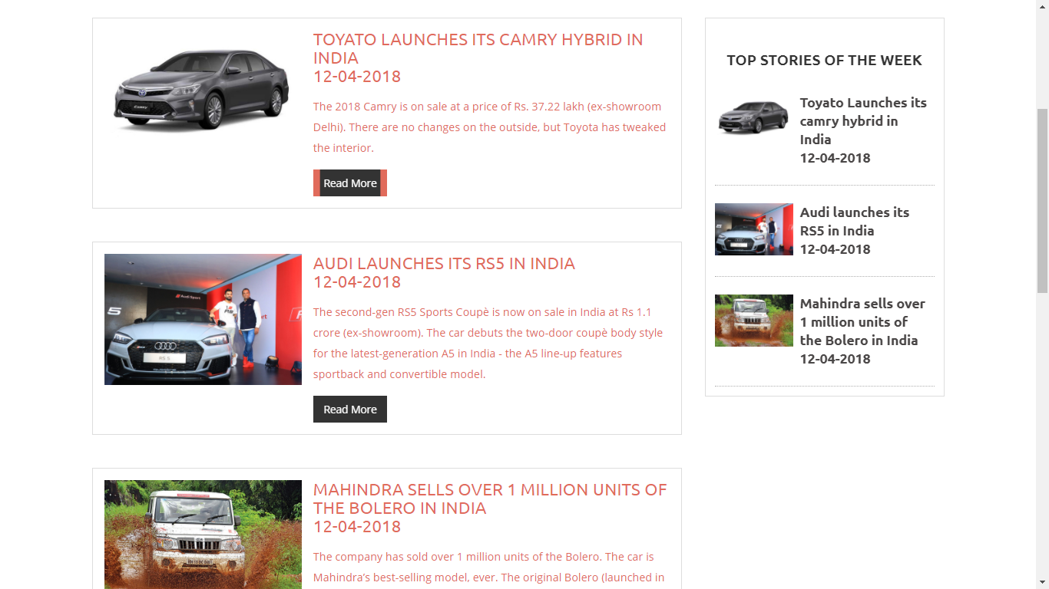

**View News(Detail):**

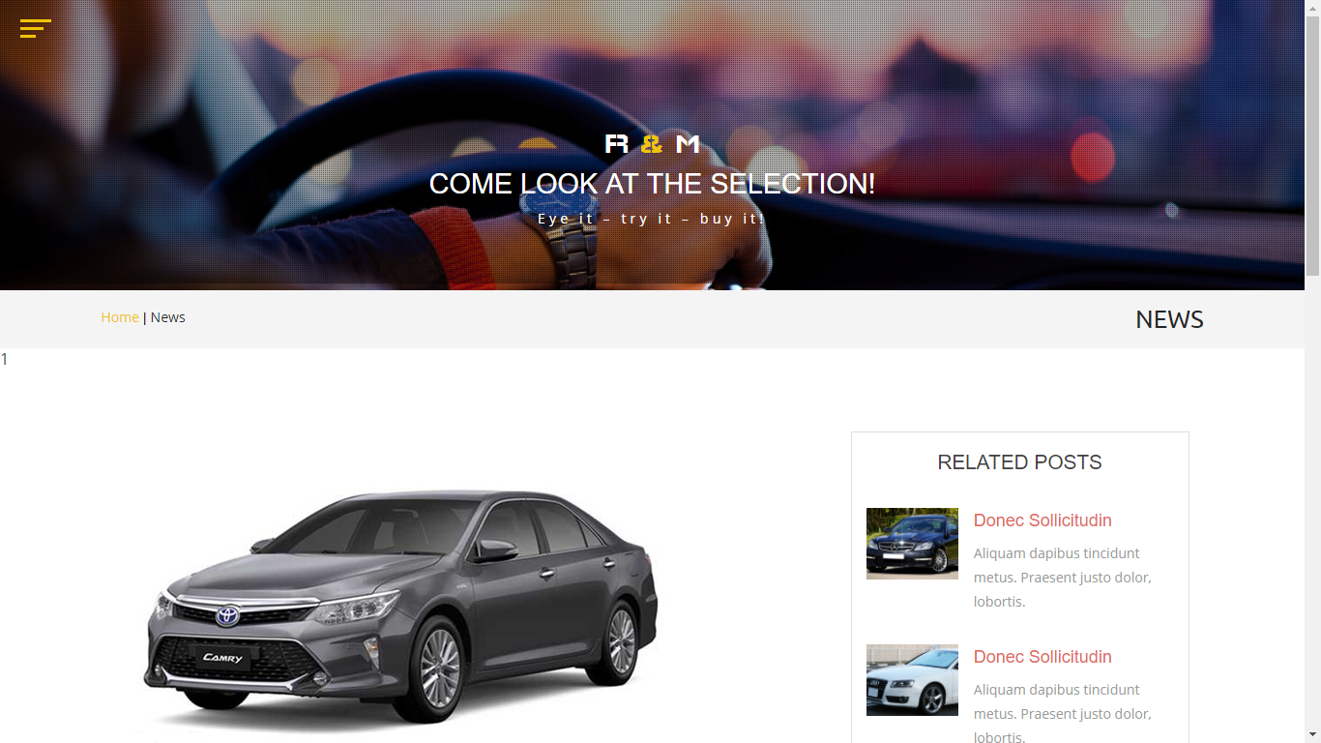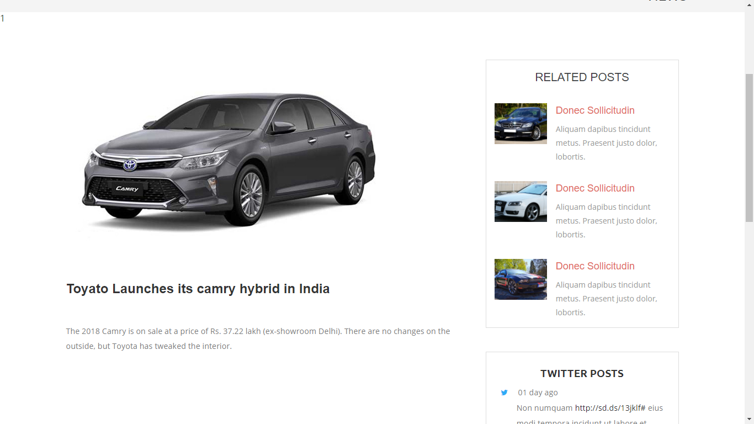

**About Us:**

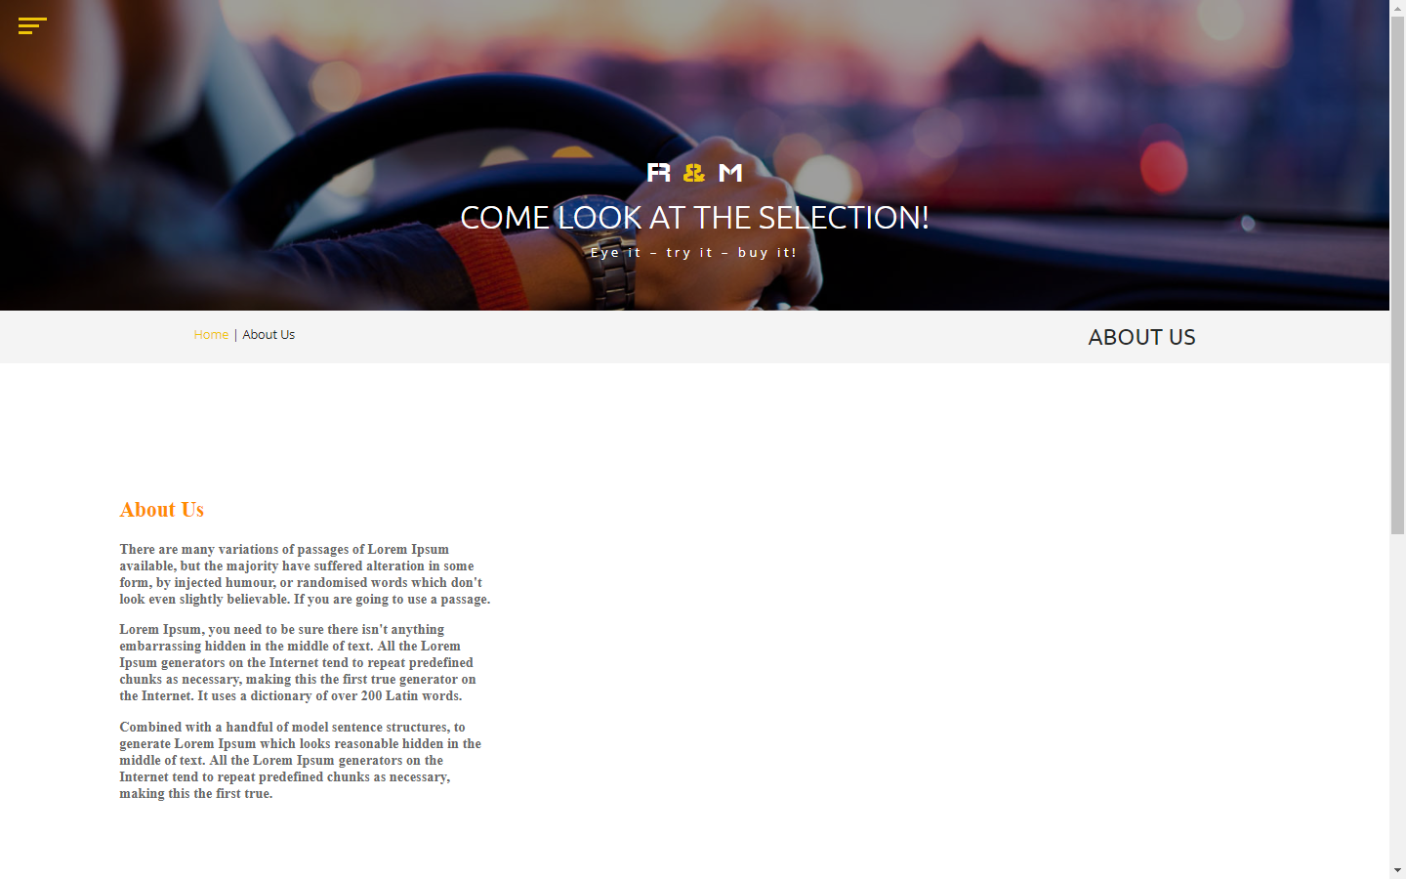

**6. Testing Report**

**6.1 Test Case Design**

The test plan focuses on how the testing for the project will proceed, which units will be tested, and what approaches (and tools) are to be used during the various stages of testing. However, it does not deal with the details of testing a unit, nor does it specify which test cases are to be used. Test case design has to be done separately for each unit. Based on the approach specified in the test plan, and the features to be tested, the test cases are designed and specified for testing the unit. Test case specification gives, for each unit to be tested, all test cases, inputs to be used in the test cases, conditions being tested by the test case, and outputs expected for those test cases. If test cases are specified in a document, the specifications look like a table of the form shown in Figure,

|  |  |  |  |  |  |
| --- | --- | --- | --- | --- | --- |
| **Sr No.** | **Flied Name** | **Input** | **Condition**  **Checked** | **Output** | **Expected Output** |
|  |  |  |  |  |  |
|  |  |  |  |  |  |

1. **Login Process :**

|  |  |  |  |  |  |
| --- | --- | --- | --- | --- | --- |
| Sr No. | Filed Name | Input | Condition Checked | Output | Expected output |
| 1 | Email ID, Password | Null | No Entry For Email ID, Username,  Password | Enter Password Is Wrong | User Login |
| 2 | EmailID | saloniPatelgmail.com | Invalid Format | Email Not Valid | User Login |
| 3 | Password | saloni123 | Valid Password | User Login | User Login |

**2) Forgot Password Process:**

|  |  |  |  |  |  |
| --- | --- | --- | --- | --- | --- |
| Test Version No. | Filed Name | Input | Condition Checked | Output | Expected output |
| 1 | Email | [salonipatel@gmail.com](mailto:salonipatel@gmail.com) | Email ID Does Not Match | Please Check Your Email ID | Please Check Your  Email ID |
| 2 | Email | [salonipatel507@gmail.com](mailto:salonipatel507@gmail.com) | Email ID Match | Entry For Email Id | Entry For Email ID |

**3) Change Password Process:**

|  |  |  |  |  |  |
| --- | --- | --- | --- | --- | --- |
| Test Version No. | Filed  Name | Input | Condition Checked | Output | Expected output |
| 1 | Old Password | Null | No Entry For Old Password | Please enter Old Password | Please Enter Old Password |
| 2 | New Password | Null | No Entry For new Password | Please Enter New Password | Please Enter New Password |
| 3 | Confirm Password | Null | No Entry For Confirm password | No Entry For Confirm password | Please Enter Confirm password |
| 4 | Old Password | 1234 | Entry For Old Password | Right Old password | Right Old password |
| 5 | New Password | 5214 | Entry For New Password | New Password | New Password |
| 6 | Confirm Password | 5214 | Confirm Password Are Match | Successfully Password Are Changed | Successfully Password Are Changed |

**4) User Registration:**

|  |  |  |  |  |  |
| --- | --- | --- | --- | --- | --- |
| Sr No. | Field name | Input | Condition Checked | Output | Expected output |
| 1 | Username | Null | No entry For Username | Username is Require | Username is Require |
| 2 | Lastname | Saloni | No valid entry for username | Lastname must be Only Character | username must be Only Character |
| 3 | Phone No | 9876545678 | Valid Phone Number | Phone Number must be 10 character | Phone Number must be 10 character |
| 4 | City | Surat | Valid City | City must be Required | City must be Required |
| 5 | Email | Salonipatel507@gmail.com | Valid Enail Id | Email must be Required | Email must Be Required |
| 6 | Password | saloni123 | Valid password  Must be 6 character  (a-z,A-Z,0-9) | Password is Correct format | Password is Correct format |

**6.2 Testing Issues**

* **Integration Testing:**

Integration testing is a systematic technique for constructing the program structure while conducting test to uncover errors associated with interfacing. The objective is to take unit tested module and build a program structure that has been dictated by design.

After our individual modules were tested out we go to the integrated to create a complete project. This integration process involves building the software and testing the resultant software for problems that arise from component interactions.

* **Black Box Testing:**

As s/w functions are operational, the set of input conditions. Exercising all functional requirements will be derived to uncover the different class of the behavioral errors such as incorrect functions, incorrect interfaces, external data structure errors, performance errors and termination errors.

* **White Box Testing:**

Based on the control structure of the procedural design, the logical paths are been exercised with specific set of conditions, loops at boundaries to examine the validity of the internal data structures.

* **Alpha Testing:**

The development site, the customer conducts an alpha test under the natural settings to record the errors and usage problems.

* **Beta Testing:**

At the customer site, the end-user conducts the “live” application test in customer environment to encounter the problems to be modified before product release.

* **System Testing:**

As the s/w is to be integrated with other system elements, system testing focuses on validating the system integration by,

* **Recovery Testing** : To assure proper recovery
* **Security Testing** : To protect the improper penetration
* **Stress Testing** : To confront the program with abnormal resources such as quantity, frequency or volume.

**7. Limitation of System**

* This system does not provide online (banking) payment transaction.
* This Site Is Only Working On National Level.
* This system can’t provide facility for booking cars online.

**8. Future Enhancement of the Project**

* This system will provide facility for advance booking of cars.
* This system will also provide the buying used cars.

**9. Reference Books**

The Following books were referred for completing this project. This is includes books for front end part and books for back end part.

* **Dewson, R. (2009). *Beginning SQL Server 2008 Express for Developers.* Apress.**
* **Foster, E. (2014). *Software Engineering.* Apress.**
* **Japikse, P. (2015). *C# 6.0 and the .NET 4.6 Framework.* Apress.**
* **MacDonald, M. (2012). *Beginning ASP.NET 4.5 in C#.* Apress.**

**Websites:**

* [www.google.com](http://www.google.com)
* www.asp.net
* www.wikipedia.com
* [www.c#dotnet.com](http://www.c#dotnet.com)
* www.cartrade.com